Proposal Summary. [L-5.1][M=n/a]

TEAM-21’s approach is to offer skilled, experienced Navy and Joint analysts, proven

leadership, and corporate facilities and resources to provide responsive analytical support

across the issues confronting the Navy in implementing SeaPower 21.

We are fully committed to the Navy’s success not only as part of the Navy/Marine Corps team, but also in the broader Joint and OSD arenas. Our team has been formed with two purposes: to be able to support the Navy in confronting the challenges of today, but equally as important, to bring the best of the analytical community to provide the innovative analyses that will be required in the years ahead. Our approach is to offer the Navy this world-class analysis support at the most economical price. We tie our success as a Company to the success of this Program by making our performance for the Navy an evaluation element in our continued Certification at CMMI Level 5. Linking our commitment to the Navy to maintaining CMMI Level 5 ensures the highest responsiveness and attention from all levels of Northrop Grumman IT and our teammates.

A.1. Purpose of the Project. To provide timely, effective analytical support to assist OPNAV in defining and implementing SEAPOWER 21 across the “trade space” of fiscal, acquisition and operational alternatives.
A.2. Basic Problems of the Project. At the conceptual level, two significant challenges dominate this project. The first is to provide effective, responsive analytic support over the broad scope of topics, issues and alternatives confronting Navy Title 10 decision-making implementing SEAPOWER 21. The second challenge involves providing the agility and expertise to advance and win support for Navy perspectives and interests in the broader Defense and Joint planning, investment and transformation decision processes such as the DODDI directed analytic agenda with DPG base case scenarios and the new capability based, Defense Readiness Reporting Systems. Analysis support is valuable to the Navy decision makers to the extent that it is witting of both the Navy perspective and of the other Joint and Defense debates to which Navy perspectives will be subjected.

Technical Approach. [L-324-a][L-5.2][M-5.2]

We need to change not only the capabilities at our disposal, but also how we think about war. All the high-tech weapons in the world will not transform the U.S. armed forces unless we also transform the way we think, the way we train, the way we exercise and the way we fight.
- Secretary of Defense Donald Rumsfeld,
National Defense University, 31 January 2002

Understanding of the Requirements Inherent in the Project.
Unlike any other time in history, today’s Navy is in the midst of a rapidly changing environment that shows no sign of abating. Change is being driven not only by emerging threats and evolving global security situation, but also by rapidly emerging technologies that enable innovative operational concepts. The Naval Operating Concept for Joint Operations, supported by Sea Power 21 and Marine Corps 21 is a vision of a precise, agile, and decisive Naval force operating and sustained from the maritime domain without limitation. This vision will lead to transformational warfighting and support capabilities of Naval forces that will be integrated into the Joint team in unprecedented ways. Multiple decision processes (Navy, Joint, OSD) occurring simultaneously, each responding to the rapidly changing environment, need to be supported by concise and innovative analyses. Now, more than ever, the Navy needs an analytical support team capable of seamlessly integrating and operating in this domain.
N81 and N70 are the principal analytical organizations supporting the Navy’s decision process. Their analysis and assessment processes are mutually supportive and complimentary to each other. Through their separate but interdependent roles in developing and integrating warfare and support analyses across OPNAV and HQMC they provide sound, high quality, unbiased and timely analysis and assessments to the Navy leadership. That analysis requires the support of an experienced, highly capable contractor team, and an effective, efficient technical approach that ensures these fundamental tenets of Navy analyses:

Sound: Founded on enduring Naval principles, satisfying strategic and tactical directives, forward-looking, considers short- and long-term capability requirements and investment priorities. This requires input, advice and guidance from seasoned, experienced Naval analysts.
- Quality. Rigorous, low risk processes - such as those provided by CMMI certified organizations - for developing and maintaining data bases, models and simulations are required.
- Unbiased. Critical, “outside the box” thinking applied to analytical problems that considers all alternatives, options and viewpoints. This requires analysts with Naval, Joint, OSD and warfighter perspectives.
- Timely. Must be done rapidly was well as deliberately. This requires a flexible, adaptive methodology and application of innovative M&S processes, tools and methodologies.
Understanding the Problems Inherent in the Project.
The Navy’s analytical community is confronted with two significant overarching problems; a rapidly changing environment and an increasingly integrated and seamless warfighting force. As a result of the former, decision-making processes in the Department of Defense are undergoing major changes. The Acquisition process; the Readiness Reporting Systems; Capabilities Based Planning; the Planning, Programming and Budgeting System; and the DPG driven Analytic Agenda are examples of major Defense decision making processes involving radical change and introducing profound new demands on the analyses supporting the Navy’s decision making. What is certain from these changes is that the Navy must change its analysis support to remain an effective force in Defense decision-making.
Dealing effectively with continued change and uncertainty in the decision-making processes is a critical consideration in selecting the Navy’s analysis support for the coming years. To be effective, the analysis team must be something more than just expert in isolated Naval warfare topics and issues. It must be Defense-wide in the depth of its expertise; and agile in its methods, measures, processes and products. The traditional, local interest oriented, analysis support of the past will not be effective in these changing, dynamic, and constantly evolving decision environments. The narrow perspectives and conceptual gaps that were the signature of the legacy analysis support to the Navy will become fatal in these new, dynamic Defense decision-making environments.
The Navy’s new analysis support must, from the beginning, be as adaptable as the warfare processes it serves. It must be agile in the focus of its expertise and products and in the scope and speed of its processes, and it must also be skilled in and continuously aware of the evolving collaborative methods and measures of the Joint Staff and OSD analysis processes in which the Navy’s perspectives and interests will be examined and judged.
The second overarching problem facing the Navy’s analytical community is the need for integration and collaboration of contractor analysis support teams not only within themselves, but also with the government’s broader analytical community. Integration and collaboration have become a “just in time” step in the process rather that a fundamental “first principal.” “Stovepipe” processes are as inappropriate for the analytical community as they are for the warfighting community. Efficiency and effectiveness of analysis is directly correlated with integration and collaboration by the contractor team.
To best serve the customer, contractor managers and analysts need to be capable of, and proactively involved with, integrating and collaborating both horizontally and vertically. To achieve this objective, two fundamental tenets must be observed. First, the mechanisms for integration and collaboration need to be built in to the technical approach. Second, an experienced contractor management and analyst team is needed to avoid the lure of “sub-optimizing” for work share or advancing proprietary tools and processes at the expense of better results for the customer.
Contractor managers and analysts also need to integrate and collaborate with government and other analysts to capitalize on their knowledge, experience and expertise. Failure to do so is, at the least, an inefficient use of available resources, and at worst, it is symptomatic of a “we’re the experts” mentality.
Finally, vertical integration and collaboration with the Joint and OSD analytical communities is needed, not to stem a rich variation of results, but to ensure analytical efforts are not divergent with overarching with guidance and vision. Integration with the Combatant Commander analytical staffs is needed to add realism and therefore ensure relevancy of the analysis. Superior technical and management approaches, such as presented by TEAM-21, are needed to realize the potential synergy of a fully integrated contractor team, collaborating with the government and with other analysts throughout the analytical community.

The TEAM-21 Solution. Just as the Armed Forces are transforming themselves into a responsive, flexible and precise joint force, TEAM-21 has been assembled to provide responsive, flexible, and precise analytical support to the Navy. We have assembled TEAM-21 and developed our Technical and Management approaches specifically to provide the finest analytical support while solving the overarching problems. The matrix below summarizes the problems, solutions, and substantial benefits discussed in this TEAM-21 proposal.

Problem | TEAM-21 Solutions | Substantial Benefits
- Need for experienced management team | - Management Approach builds experienced management team with executive-level involvement  - Corporate commitment to excellence | - Reduced government oversight requirements  - Reduced execution risk  - Best results
- Need for integration within the contractor team and government analytical community  - Need to focus on best team member to do the job  - Need to focus on best tools for | - Integrated TEAM approach designed-in  - Experienced managers, analysts  - NATIC  - Focus on analytical requirement to drive selection of who and what tools | - Synergy, collaboration with Navy, Joint, OSD and Combatant Commander analysts  - Full analytical capability in one team
- Need for analysts that can keep pace with rapidly-changing Defense decision-making environment | - High quality, experienced analysts  - Joint, OSD experience  - Ties to broader analytical community | - High quality results  - Agility in dynamic environment  - Joint, OSD expertise
- Innovation needed in tools, methodologies to address current needs | - Innovative application of M,S&A technologies, tools and methods | - New capabilities to address challenging analytical issues
- Need to have flexible, adaptable processes | - CMMI Level 5 management processes accommodate change | - Very low risk
- Need for an unbiased, objective analysis team | - Honest broker  - OCI plan | - Unbiased, objective analysis

How Was TEAM-21 Formed? TEAM-21 was formed with strong consideration towards providing a solution for substantial benefit to the government. The selection of Northrop Grumman IT as prime provides a veteran management team with recent experience in projects of similar size and scope such as the Joint Analytical Support Program (JASP). Northrop Grumman IT also has in place a CMMI Level 5 management process to accommodate the rapid change described previously in this section. Northrop Grumman IT has modern facilities to support the tools and processes needed for classified and unclassified modeling, simulation and analysis. This facility is located within 2 miles of the Pentagon is equipped with SIPRNET. Finally, from an enterprise perspective, Northrop Grumman IT is a, stable, and financially secure business sector. This substantially relieves profitability pressures and focuses attention on the distribution of work to teammates (not referred to as “subs”, except as required in Section D) best positioned to answer the analytical requirements of the solicitation.
The selection of teammates was a comprehensive and lengthy process, but one that resulted in an exceptional outcome. The one inviolable prerequisite of all teammates was that they have a substantial, documented record of superior past performance that unquestionably exceeded the requirements of the government customers. Beyond that, teammates were selected based on their expertise and experience in supporting analytical processes relevant to the SOW, both for the Navy/Marine Corps team and for the broader Defense community. Of no less importance, each teammate was selected based on their motivation to provide substantial benefit to the Navy through an integrated, supportive, and collaborative process. Finally, teammates were selected in compliance with the requirements of the solicitation, with regard to type of business. Table B-1 shows the general experience, expertise, and business type of the TEAM-21 teammates.
Table B-1. Selection Criteria for Teammates
Name of Business | Experience and Expertise | Type of Business
AT&T  (Government Solutions) | - Currently supporting OSD (SAC), Joint Staff  - Database maintenance and dev.  - Model and simulation maintenance and dev.  - OPSIT development  - Campaign analysis  - Manpower and personnel analysis | Large
Booz Allen Hamilton | - Currently supporting N70, N81  - Warfare and support area analyses  - Capability characterization measures dev.  - War game/seminar support  - Long range planning  - Special studies  - C4ISR, NCW, EBO M&S  - Cost analysis | Large
EDO | - Previous support to N81  - Data base development and maintenance | Large
Gryphon Technologies | - Currently supporting Navy and Marine Corps  - Technology assessments | Woman Owned Small and Disadvantaged
Northrop Grumman IT  (MSAC) | - Currently supporting N81, HQMC (P&R), Joint Staff (JASP)  - Warfare and support area analysis  - Common frame of reference dev.  - Investment strategy development  - Campaign analysis  - Scenario development  - Cost analysis  - Special studies  - Logistics analysis | Large
Office Solutions for the 21st Century | - Previous senior level experience in N81 and SPAWAR  - Training and education  - Administrative and technical support | Woman Owned Small
Red Pen, Inc. | - Technical support | Woman Owned Small
The Analysis Group  (TAG-LCC) | - Warfare and support analysis and integration | Veteran Owned Small
Whitney, Bradley & Brown (WBB) | - Currently supporting N81, N70, USMC  - Warfare and support area analysis  - Force structure analysis  - Decision analysis  - Manpower, personnel, training analysis  - Special studies  - Infrastructure analysis | Large

How will TEAM-21 be functionally organized? The team is integrated, both from a location and a management perspective. Figure B-1 shows the approach used to capture both synergy and innovation, to allow quick turn analyses, and mitigate any risks in terms of coordination with the government and within the team. The focus of this structure is on the Naval Analytic Team Integration Cell (NATIC) and the N81/N70 Onsite Team Support. The onsite team will consist of the more senior analysts with familiarity to OPNAV, HQMC, Joint Staff, and OSD processes with ties to the various warfighters. The individuals at the NATIC will also be experienced technical and analytical analysts and will share “knowledge” with the onsite personnel. During surge and short-term analysis requirements, the location of these personnel will be transparent to the government. The risks to schedule and responsiveness to customer expectations will be mitigated by this innovative arrangement that drives close coordination in assignments, tool selection and analysis methodologies.
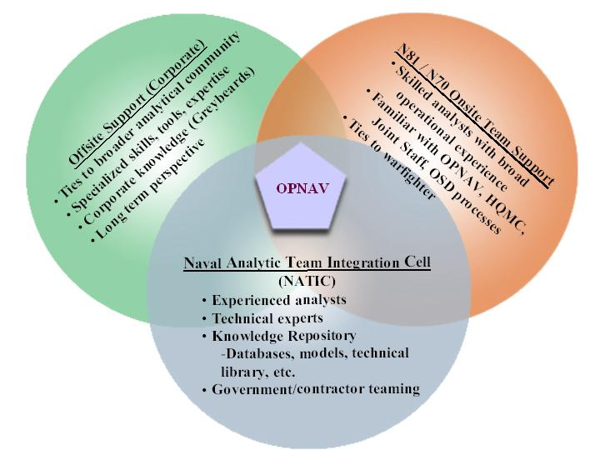
Figure B-1 Support to OPNAV assessment process will be provided through innovative approach developed specifically to capture the synergy of government and contractor analysts working together.

TEAM-21, through the onsite analysis team, will coordinate with government analysts to define and develop analysis requirements, and ensure analysis processes and results are in line with evolving Navy concepts. Through the NATIC, TEAM-21 will apply the tools and methodologies needed to answer study issues. The NATIC also will facilitate faster, more thorough results by exploiting the knowledge repository, extensive tool suite, collocated analysts, and reachback to other TEAM-21 and corporate capabilities. Additionally the NATIC can link to other Joint organizations to draw on existing data and expertise.

B.1. Statement of Work Areas. [L5.2.1][SOW 2.0] The Service’s Planning, Programming and Budgeting System (PPBS) is the framework for the requirements and acquisition process and needs to be supported by effective and efficient analyses. Since analysis requirements must be clear to the contractors that support the process, this section describes TEAM-21’s in-depth and detailed understanding of the processes involved and the analyses required within N81/N70 and shown in Figure B-2.
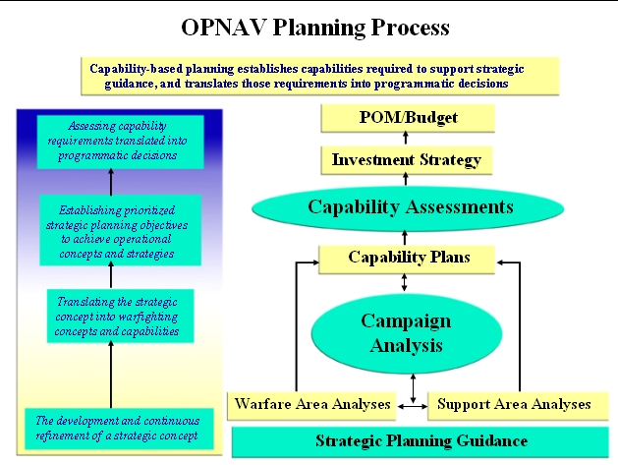
Figure B-2. Capability based planning establishes capabilities required to support strategic guidance,
and translates those requirements into programmatic decisions.

Naval operational requirements are generated and assessed through a capability-based planning process that guides and informs programmatic decisions. Capability-based planning focuses on determining how adversaries might fight rather than whom the adversaries might be or where a war might erupt. It is through capability-based analysis and assessments that the critical linkage among strategy, objectives, tasks and required capabilities are maintained. Capability-based planning identifies deficiencies or redundancies across multiple time horizons in a variety of scenarios to determine the alternate mixes of capabilities and informs current and future investment strategies.

Within OPNAV, N6/7 is charged with developing the Service’s warfighting capability plans. N1, N4 and N00T develop the support capability plans. Warfighting requirements are analyzed, aligned and evaluated by mission area in Mission Capability Packages (MCPs) through the Battleforce Capability Assessment and Programming Process (BCAPP). MCPs are “rolled-up” into Naval Capability Plans (NCPs - now Mission Capability Plans) that are aligned with the SEAPOWER 21 pillars. A key N6/7 product of Naval Capability Development Process (NCDP) is a fiscally informed document that considers short- and long-term capability requirements and investment priorities – the Integrated Strategic Capability Plan (ISCP). N6/7 is also responsible for the final product in the capability development process leading to the POM and the Integrated Sponsor Program Proposal (ISPP), which programs the Navy’s warfighting resources.

The OPNAV assessment program led by N81 is a modeling, simulation and analytically based assessment of Capability Sponsors’ products. This assessment process supports and is complimentary to the NCDP. N81 further assists the assessment process by providing campaign analysis support for OPNAV. The consolidated results of the assessment process are provided in the CNO’s Investment Strategy (IS) that presents alternative current and future investment strategies for the Navy.

The goal of the PPBS is to ensure “warfighting wholeness,” introduce transformational proposals and innovative concepts, and create a vision for the Navy and Marine Corps team that will field enhanced joint capabilities for the joint warfighting forces. The attainment of this goal requires analytical thinking, which in today’s environment must be “outside the box” to enable concept developers to transform strategic goals into meaningful planning objectives.

The Navy needs concise and innovative analyses to help guide Navy programming and investment decisions while transitioning to and implementing the SEAPOWER 21 guidance. TEAM-21 will define and implement a methodology that supports the full spectrum of N81/N70 analysis requirements and provides innovation in analytical approaches and techniques facilitating evaluation of warfighting requirements and assessment issues. Leveraging its experience and legacy of support to OPNAV and other Joint and Service departments, TEAM-21 will provide full-capability through an experienced and highly skilled onsite analysis team supported by a nearby analysis facility (the Naval Analysis TEAM-21 Integration Cell – NATIC) staffed with equally qualified analysts and modelers. This facility is equipped with the latest computing and visualization hardware, cost and combat modeling software, and will be connected via SIPRNET to the onsite team. This facility is patterned using the successful OSD Simulation and Analysis Center (SAC) business model that integrates contractor and government analysts. To meet both surge and/or special analysis requirements the onsite team will be augmented from the NATIC to provide a “knowledge multiplier” ensuring N81/N70 will receive prompt, relevant and focused analysis. Through the use of its corporate networks, which presently link to many naval, joint, government and industry organizations, TEAM-21 will engage extensive analysis resources and expert personnel with which to scope and resolve important OPNAV issues.
In the final paragraphs of this introduction we present the Technical Approach top-level methodology. We show how this approach is compliant with the general requirements of the SOW; how the inputs, general process, and major products relate to the overall PPBS process; and describe the key features. In Section B.1.A and subsequent sections, we discuss each requirement of the SOW, state the problems/issues associated with the task, validate TEAM-21’s relevant experience, detail our approach to accomplishing the work, and articulate the benefits to the government. Note that the depiction of the general tasks represented in the top-level methodology in this section is relevant to the PPBS, while the sequence of tasks presented in the detailed discussions beginning in Section B.1.A is as the tasks are listed in the SOW.
Finally, we present the two sample tasks. Our approach to the first sample task example demonstrates an innovative capability-based approach to a classical force structure problem using the methodology and tools discussed in this document. The second example highlights our ability to meet emerging analytical challenges using innovative thinking, tools and methodologies also presented in this document. These tasks clearly demonstrate TEAM-21’s ability to analyze, evaluate and synthesize requirements into approaches, plans and techniques to yield exceptional, effective and efficient performance.
The top-level analytical methodology supporting N81/N70 is shown in Figure B-3. The processes are correlated to RFP paragraph numbers. A detailed technical description of each process will be found in later parts of this proposal. This section focuses on the manner in which the various analysis processes relate to and integrate with each other. Three significant features of our proposed methodology are: integrated task execution; centralized knowledge repository, and detailed sensitivity analyses.

Figure B-3. TEAM-21 will provide a broad spectrum of analytical support to the OPNAV PPBS process.

The methodology integrates the processes based on common, agreed-upon inputs and frames of reference. The knowledge repository is generated and built-up through the PPBS cycles and will be a compendium of issues, models, results, decisions, program and system data, and projections of future naval technologies and capabilities. The knowledge repository could be hosted on a secure Website to enable the sponsor to provide for distributed analyses with other organizations.

Sensitivity analyses will quantify the effects of changes or uncertainties in parameters driving the NCP/MCP and Warfare and Support analyses and assessments to increase the confidence of point solutions. TEAM-21 will conduct complementary analyses using the knowledge repository, federated tools, and metrics to identify capability break points.

The OPNAV planning process drives our methodology. The current planning cycle generates, or carries over from earlier cycles, significant programmatic, doctrinal and operational issues that need to be resolved with the aid of analysis. TEAM-21’s methodology, through the performance of the various analyses shown in this figure, will support the OPNAV vision of conducting and integrating concise and innovative analyses that inform programmatic decisions.

B.1.A. Warfare and Support Assessments. [L-5.2.1A][SOW 3.2][M5.2.1A][M307(c)-1.1(a)]
TEAM-21 provides the highest caliber of operations research and military analysts with

experience and expertise in the full range of Naval and Joint warfare and support analyses

and unparalleled operational experience in Naval and Joint operational environments.

Warfare and support assessments are a critical part of the capability-based planning process. The major elements of warfare and support assessments are a common frame of reference development, operational situation (OPSIT) development, analysis, long-range planning support, and war game/seminar support. Figure B-4 shows how these elements relate to the capability-based planning process.

B.1.A(1) Common Frame of Reference Development. [L-5.2.1-A(1)][SOW 3.2.2] [M-5.2.1-A(1)]
TEAM-21 has broad experience with a wide range of customers in developing a common frame of reference and is currently supporting OPNAV, HQMC, Joint Staff, and OSD for warfighting and support assessments (e.g., PR-05 Force Structure Study Review for N70).

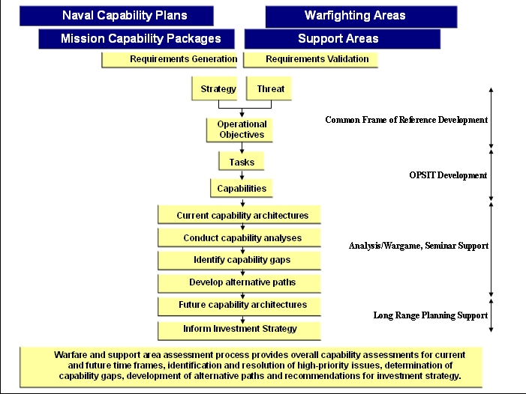
Figure B-4. Major elements of warfare and support assessments are integral to the
overall capability to the based planning process.

(a) Objective. [SOW 3.2.2.1] We will develop a common frame of reference by validating, integrating, refining, and aligning naval, joint, and coalition CONOPS, data, scenarios, and assumptions. We will ensure the common frame of reference supports coherent, consistent, and relevant analyses.
(b) Work Statement. [SOW 3.2.2.2] Developing the Common Frame of Reference cannot be done piecemeal. The supporting team must be capable of reaching out to stakeholders and getting their inputs in developing the CFR. If the team does not have the resources to meet all CFR requirements, then they will not be capable of providing end-to-end support throughout all of the requirements of this solicitation.
TEAM-21 is currently supporting OPNAV, HQMC, Joint Staff, and OSD for warfighting and support assessments (e.g., PR-05 Force Structure Study Review for N70) in developing common frames of reference for their respective analysis requirements. The common frame of reference provides a context for comparing analysis results. As displayed in Figure B-5 TEAM-21’s approach to developing the Common Frame of Reference (CFR) requires capturing inputs from Sources including Navy, Naval, and Joint/Allied/Coalition requirements and operations to ensure that subsequent analyses, conclusions, and investment recommendations are responsive to warfighting requirements and result in the most efficient resource utilization. The CFR will be used as the baseline for analysis; therefore, the CFR also will include Inputs such as assumptions, scenarios, CONOPs, and data. Where absent, or not responsive to analysis requirements, TEAM-21 has the ability to provide drafts for OPNAV IPT consideration and the ability to make all necessary adjustments subsequent to IPT review. Coordinating drafts with cognizant personnel should be an expected requirement for TEAM 21. The CFR then becomes part of the knowledge repository database. From here, TEAM-21 is then positioned to use the CFR to apply scenarios to mission, campaign and warfare, and support assessments. Vetting the CFR with the appropriate organizations is important to the credibility of the CFR. It is anticipated that the CFR will be a living document, constantly being adjusted to capture the dynamics of the changing world order and evolving demands of the resourcing and decision processes.

Figure B-5. Common Frame of Reference Development

B.1.A(2) Operational Situation (OPSIT) Development. [L.5.2.1.A(2)][SOW 3.2.3][M-5.2.1-A(2)] Developing OPSITs requires a team that is warfighter savvy, and has those warfighters involved in all aspects of OPSIT development through the use and application of those OPSITs in addressing capability issues. TEAM-21 has extensive experience developing scenarios and OPSITs for OPNAV to evaluate C4ISR and Expeditionary Operations and has developed numerous “use” cases highlighting specific Naval capabilities and emerging systems for BFC2, Expeditionary Warfare, and Strike MCP analysis in POM-04 and PR-05 and in assisting in JWARS development. Also, we have been developing JASP OPSITs for the CoCOMs, and for OSD that are being used to investigate how new weapon systems could be employed and how Naval forces could participate in Joint scenarios.

Our team mates were central to the scenario development working groups for the OSD SAC Mobility Requirements Study 2005 (MRS-05) and the JCS led, DPG directed Operation Availability (OA) study. Leveraging these qualifications will ensure ties to joint war fighting requirements and OPSITs as required for Naval analyses. Across TEAM-21 we have Naval and Joint operational experience in all warfare areas and analytical expertise to capture naval and joint force requirements and operations in current and emerging environments. TEAM-21 successfully use a mature scenario scripting process in our USMC Mission Area Analysis to develop realistic, valid, and relevant OPSITs based on Defense Planning Scenarios. Our experience in defining detailed timelines, force sequences, threat, support requirements, etc. will support mission and campaign analysis. Developing OPSITs will go hand-in-hand with developing capability characterization measures. Perhaps most important, we are prepared to respond quickly with new OPSITs to enable analysis in anticipation of, or in reaction to changing world events. Figure B-6 depicts a Straits of Hormuz backdrop for scenario development. Some of the many factors in OPSIT development include characterizing the Red forces, i.e., Threat Characterization and Tactics, representing the Physical Environment, capturing the Timelines and required logistics, and representing the Blue Concept of Operations and Force Laydown. The OPSITs will be developed in consideration of an overarching Joint Campaign Context.

Figure B-6. OPSITs will be developed at a level of detail
sufficient to support high-resolution assessments.

OPSIT development must be consistent with current Naval doctrine. OPSIT excursions must embrace evolving doctrine and forge employment strategies enabled by new weapons systems and tactics. Leveraging our positioning and experience in OSD, Joint and CoCOM organizations will ensure OPSITs are consistent with established scenarios. The OPSITs that we develop will become part of a larger database of knowledge that will be leveraged for future analyses. As our forces face new and sometimes asymmetric threats, we will be able to establish quickly an analytical framework with OPSITS that will respond to these emerging threats as well as OSD and Joint guidance in the employment of Naval forces.

B.1.A(3) Analysis. [L.5.2.A(3)][SOW 3.2.4][M-5.2.1-A(3)]

Team 21 is engaged now in POM-06 support and supported N81/N70 analyses for POM-04

and PR-05.

(a) Objective. [SOW3.2.4.1] TEAM-21 will provide analyses supporting warfare assessment processes. We will use the rigorous but tailorable methodology shown in Figure B-7 to develop a comprehensive study plan that will be coordinated and regularly reviewed with the customer.

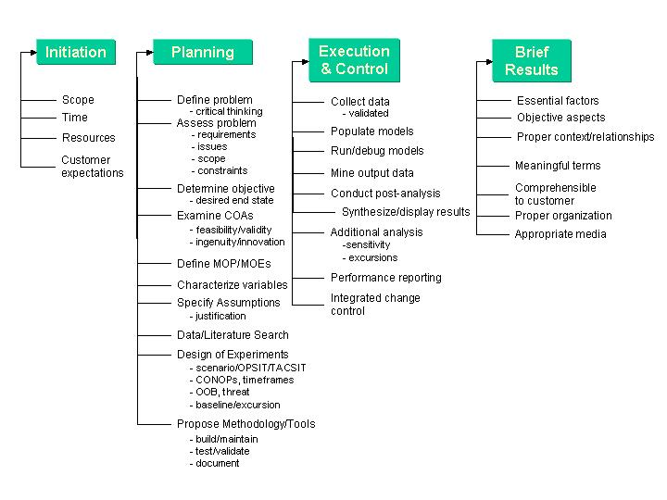
Figure B-7. An established methodology reduces risk and improves quality results.

This methodology ensures the analysis will be structured and our progress will be measurable from task start through the presentation of deliverables. At Initiation, customer expectations will be established including the frequency and scope of face-to-face meetings to ensure there are no surprises, particularly as the task is drawing to a close. Planning lays out the road map for task execution including a critical appraisal of the requirement, framing the end state, defining capability characterizations (MOE/MOP), and determining the role of experimentation, wargaming/seminars, and S&T in the task. Execution and Control spans data collection, prepping models, simulation runs, and integrating other analysis and wargame inputs. Lastly, Brief Results captures the end-to-end products of the analysis and packages the results ensuring they meet the customer’s needs. This process leads to a comprehensive study plan that will be coordinated and reviewed regularly with the customer. Quality is built in from the start, work is done correctly the first time, and the client knows exactly what will be delivered.

(b) Work Statement. [SOW 3.2.4.2] Direct interface with the client will be performed by TEAM-21 personnel embedded in N81 and N70. It is anticipated that most analyses will be conducted at the NATIC. Remote work will be done only when necessary for efficient resource use; however, such work will be an extension of the NATIC. The analytic methodology that will be used for analyses and assessments is shown in Figure B-8. Data inputs in the top left of the Figure, include Blue Weapon and Platform Alternatives, and Blue Missions and CONOPS and Scenarios, etc. Weapon and platform alternatives will include a base case plus variations identified during the development of the common frame of reference. Inputs will be based on SEAPOWER 21 pillars and support area analyses, e.g., Sea Trial as shown on the right of the Figure-B-8.

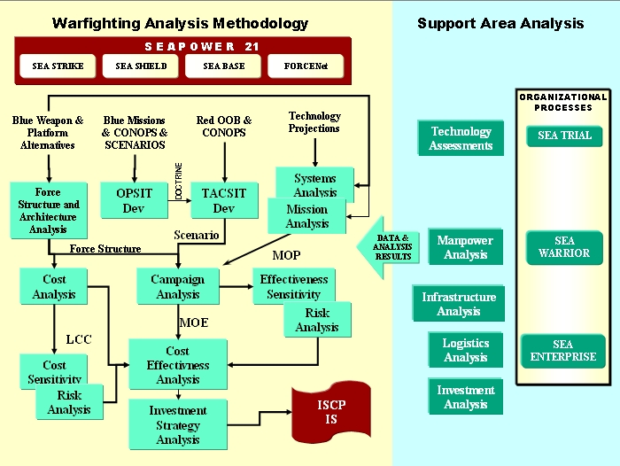
Figure B-8. This methodology builds on commonality of analysis requirements supporting N81 and N70.

This methodology captures the discreet analysis elements discussed throughout this proposal. A Force Structure baseline will be defined (or provided) appropriate to the purpose of the analysis. Using the DoD Architecture Framework will assist in defining the dependencies and relationships within the Force Structure. Our groundbreaking use of the Framework supporting ASN RDA CHENG and several MCPs in POM-04 and PR-05 will be leveraged heavily supporting all analysis phases.

No one can match the breadth of experience that TEAM-21 offers in using the Framework and applying its products to support capability and gap analysis and subsequent investment alternatives. Further, only TEAM-21 has demonstrated the capability to perform the necessary analysis to distill the Framework data into actionable alternatives for programmatic, schedule and investment decisions. This was clearly demonstrated through alternatives developed for the BFC2 and Strike MCPs in POM-04 and PR-05. OPSITs and TACSITs will be developed and Technology will be explored as a means of closing capability gaps and also to improve current or planned capabilities. Measurable Capability Characterization Measures (MOP in the Figure) will be selected to enable sensitivity analysis. Mission Analysis will be aggregated as inputs to Campaign and Cost Analysis. Campaign analysis will quantify capability by means of combat simulations. Comparative life cycle cost (LCC) estimates will be developed for alternatives and will be used for cost-effectiveness comparisons of the alternatives, for Cost Sensitivity excursions and Risk Analysis. Sensitivity and risk analyses will be factored into an overall Cost Effectiveness Analysis to provide the final inputs to developing an Investment Strategy that in turn becomes an input to the ISCP Investment Strategy. Results and data will be used as inputs to the investment analyses referenced in section B.1.B.

(c) Deliverable Products and Schedules Specific to Analysis. [SOW 3.2.4.3] Deliverable products and schedules may include study plans, schedules, briefing slides, study reports, input and output data, and data that has been synthesized for analysis following model and simulation runs. Specifics of these products and reports are described in section B.1.F.
(d) NEED A TITLE (CERs) [SOW 3.2.4.4] ALSO NEED A WRITEUP for this paragraph.

B.1.A(4) Long-range Planning Support. [L.5.2.A(4)][SOW 3.2.5][M-5.2.1-A(4)] Long Range Planning requires an ability to see the changing world order and the ability to reach out with operationally and analytically experienced personnel who can recognize current and potential capability shortfalls, and blend that into mission, campaign and analysis support. TEAM-21’s long-range planning experience has grown with the expanding horizon in Navy’s planning processes. Specifically, TEAM-21 supported selected warfighting MCPs in their mission capability forecasting and coordinated with the intelligence community to ensure comprehensive long-range planning. TEAM-21 has supported the OPNAV planning and decision making processes with the difficult trades between buying for today’s immediate requirements, investing in planned systems, and deciding when to accept risk and leap ahead.

(a) Objective. [SOW 3.2.5.1] Long-range planning support will be accomplished according to a process (Figure B-10) developed by TEAM-21 that uses the results of seminars, war games, and Modeling, Simulation, and Analysis (MS&A). We will tailor this methodology for application to OPNAV and will use the common frame of reference of the current planning cycle. Our focus will be far term and we will be responsive to the overarching strategic vision for Naval and Joint forces. We will identify and prioritize future requirements and capabilities, identify shortfalls or redundancies, and lay out an investment strategy to achieve the desired capabilities.

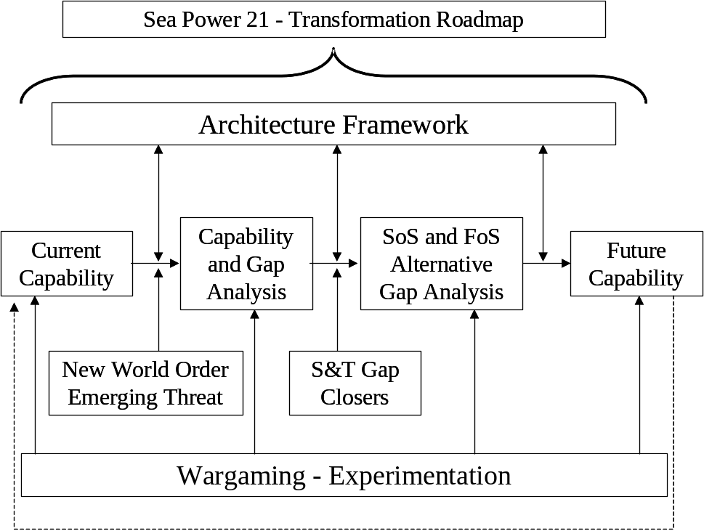
(b) Work Statement. [SOW 3.2.5.2] Figure B-9 establishes the framework for long-range planning. This approach was employed in capability analyses for the ASN RDA CHENG supporting the MCPs, as well as directly for selected MCPs. We linked the National Security Strategy to the Naval Operating Concept for Joint Operations, SeaPoweR 21 and the Transformation Roadmap to capture future requirements and capabilities. We coordinated with the Intelligence community, Resource Sponsors, Program Managers, and the warfighting communities to characterizes the New World Order, identify future threats and the requirement for legacy system upgrades or development of new systems. We also identified S&T Gap Closers that could be applied to capability shortfalls.

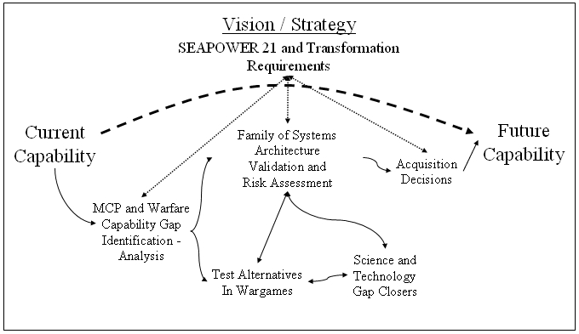
Figure B-9. Long Range Planning Requirements.

As discussed in Section B.1.A(5), War Game/Seminar Support, TEAM-21’s Wargaming capability will be applied to long-range planning. Long-range planning will also be supported by Experimentation. TEAM-21 will leverage our leadership role in developing Fleet Battle Experiments (Deputy Director for experiment development) and Sea Trial activities, as well as Sea Warrior activities in evaluations supporting DOTMLPF (Doctrine, Organization, Training, Materiel, Leadership and Education, People, and Facilities) to meet future challenges to our defense strategy. JFCOM’s series of Integrating and Functional Concepts, which are tested through experimentation, also will be leveraged for DOTMLPF recommendations. DoN’s and DoD’s investment in S&T will be explored and leveraged as a hedge against future uncertainty.

Figure B-10 is a notional Capability Evolution Description (CED) that TEAM-21 prepared for the Strike MCP during PR-05 to address the Strike challenges of engaging mobile and moving targets. Detailed Strike CEDs were developed with specific capability evolutions depicted.

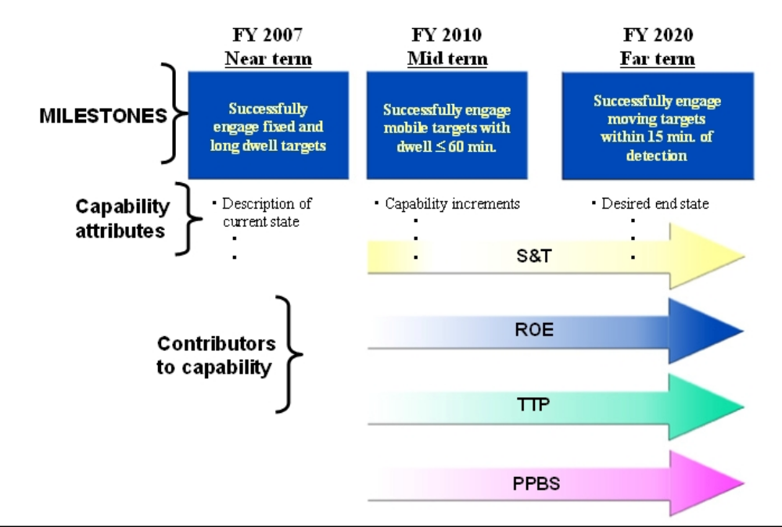
Figure B-10. An example of our approach to long-range planning was used to support a

time-critical targeting Capability Evolution Description (CED).

This figure shows capability milestones increasing from being able to engage stationary targets by FY07 (requires defeating cover and deception) to successfully engaging moving targets in the far term, FY20 in this example. When detail is added to this CED, it would identify the Capability Attributes required to reach the next milestone. Contributors to this Capability come from S&T, TTP (Tactics, Techniques and Procedures), would address capability gaps and shape the future Strike capability. Successfully executing long range planning responds to top-level direction, ensure the force is prepared to fight a Naval or Joint campaign, and leverages every investment dollar into providing the warfighting the best capability.

B.1.A(5) War Game/Seminar Support. [L.5.2.A (5)][SOW 3.2.6][M-5.2.1-A (5)] TEAM-21 has extensive experience in planning, conducting, facilitating, analyzing, and reporting war games and seminars across the DoD. For example, we conducted DD-21 for the Navy, Agile Dancer games for USSPACECOM, seminars assessing cyber incidents for National Security Agency, and Naval Information Operations Wargame games for FIWC. We designed the Welkin Gemstone war game at the SCI/SI/TK/B level for the National Imagery and Mapping Agency and provided a SCIF to accommodate 40 participants. Over the past five years, TEAM-21 has supported planning and execution of thirteen Level IV Anti-Terrorism Executive Seminars with over 1,400 participants and two major Anti-Terrorism Conferences.

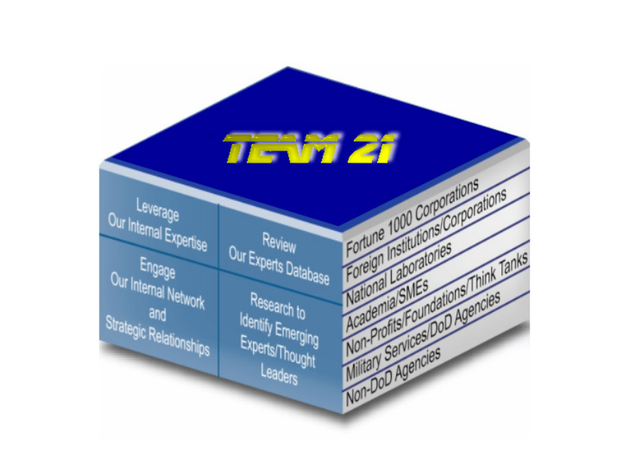
(a) Objective. [SOW 3.2.6.1] TEAM-21 will conduct and facilitate wargames and seminars using the latest technology and multimedia resources as an integral component to warfighting and support analyses as shown in Figure B-11.
Figure B-11. TEAM-21’s approach to providing
integrated support to the OPNAV assessment process.

We will customize our wargaming and seminar formats to fit the clients’ requirements, rather than forcing issues and problem solving into a fixed template. We will provide our state-of-the-art facilities (e.g., multimedia, groupware, SCIF, SIPRNET, group visualization) and attend to all administrative matters.

(b) Work Statement. [SOW 3.2.6.2] Wargaming is the forum to explore new ideas in responding to rapidly evolving changes in the new world order. Capabilities will be evaluated and gaps identified using subject experts to assess new concepts and ideas. Our wargames will be built on the Common Frame of Reference; drawing data from the knowledge repository, and other credible sources, and will be the genesis of a common data source for the client that will include programmatic facts, data from reports, analyses, and experiments, as well as empirical data. Integrating players via remote access, or on a game floor using groupware will expand the opportunities for participation and assist in capturing specific inputs and nuances. Our approach will include thorough issue research, alternate approaches for the client’s consideration, tool selection that fits the problem, scripting the game, developing a data capture plan, providing subject experts with requisite facilitation skills, action summaries for client approval, and dissemination of game materials. Given this construct, and by selecting the appropriate tools, data reduction and analysis will be timely. Further, this data could be available for other analyses, game reconstruction, and quick-look briefings and detailed reports as it becomes part of the knowledge repository. Our wargame methodology is applicable to operations, investment decisions, issue resolution, strategic planning, and program support. Our war gaming can be a stand-alone activity or part of a larger strategy where war gaming is combined with modeling and simulation to address issues. Regardless, our proficiency at war gaming will provide the client an effective forum to explore “on the fly” evaluation of CONOPs and new tactics, techniques, and procedures responding to the GOWT and as yet unforeseen emerging changes in the world order. We are ready to accompany the client in reaching beyond the norm and our personnel are operationally and analytically prepared to step “out of the box” in using current or new tools in a wargaming venue.

(c) Deliverable Products and Schedule. [SOW 3.2.6.3]

Deliverable products and schedules may include comprehensive, interactive after-action summaries including read-aheads, executive summaries, agenda, presentations, reports, questions and discussions, and a library of current publications. Specifics of these products and reports are described in section B.1.F.

B.1.B. CNO’s Investment Strategy. [L-5.2.1-B][SOW 3.3][M-5.2.1-B][M-307(c)1.1b]
TEAM-21 is exceptionally well qualified to support the continual development and

refinement of the Investment Strategy, which supports Navy program planning.

In the end game, developing recommendations for the CNO’s Investment Strategy is greatly dependent on the insight that the supporting analysis team brings to the analysis activities that established the Investment Strategy foundation. The Investment Strategy is where the ‘whole really is greater than the sum of the parts.’ Developing the Investment Strategy is an end-to-end process that requires understanding and being able to execute the discrete process components. More importantly, the supporting team must be able to fit the pieces together and understand the “how and why” of that process. TEAM-21 has demonstrated this insight throughout our discussion of the discrete parts of this proposal. Examples of our recent Navy/Marine work supporting investment analysis include the TACAIR Aviation Integration (A3I) Study for CNO/CMC, developing the CPAM (now CNO’s Investment Strategy (IS)) for N81 and the ISCP/Capability Gap Analysis for N70. Our current experience and exemplary performance with all phases of the PPBS (now PPBE) are clear indications of our ability to develop and refine the Investment Strategy. Our team has active duty and civilian experience in organizations performing requirements generation (N1/N2/N4/N6/7/N8 including warfare sponsors), program assessments (N70, N81, MCCDC, Joint Staff, CoCOMs, OSD(PA&E)), programming (N80, HQMC(P&R)), SYSCOMs (NAVAIR, NAVSEA, SPAWAR, MARCORSYSCOM), and service cost estimates (NCCA)

B.1.B(1) Purpose. [SOW 3.3.1] TEAM-21 will support the continual development and refinement of the IS through iterative and integrated government-contractor teaming process as represented in Figure B-13. We will integrate the wide range of warfare and support analyses with overarching guidance to determine Naval force capability requirements and align these requirements with the SEAPOWER 21 warfighting areas and functional enablers (SEA ENTERPRISE, etc.). We will conduct cost-effectiveness analysis and risk analysis to develop feasible alternative investment strategies. Each alternative will be assessed in terms of warfighting wholeness, affordability, and overarching guidance. We will use our state-of-the-art decision analysis tools and methodologies to present IS options in a clear and concise manner. At every step of this effort, TEAM-21 will document the decisions and supporting rationale. This documentation will be used to prepare the IS and will be an input to the Programming Guidance.
B.1.B(2) Work Statement. [SOW 3.3.2] Figure B-12 is a detailed depiction of the Investment Strategy development process. While not explicitly shown, all SOW areas contribute to realizing an Investment Strategy. TEAM-21 was able to characterize the process in this Figure because we have developed all of the process components; have been on the cutting edge of all facets of capability assessments; and we have been developing investment strategies as discussed at the beginning of this section. Developing the IS begins with a Baseline, usually the Program of Record (POR). TEAM-21’s hands-on knowledge and expertise with the Program and Budgeting Information System enables Baseline Input changes for “fact of life” adjustments, new top line constraints, etc. Overarching program and fiscal Guidance such as the CNO Guidance and Strategic Priorities, and CNO and NMCB Focus Issues also have implications for the IS. Capability Integration is introduced to the process by capability assessments, warfighting and support assessments, and N70 Gap Analysis. Validation and Integration is introduced through performance models and limited objective experiments (LOE) contributions to the Baseline Strategy. Key Interdependencies include current validated pricing data to support cost trades. Additional analyses (technology assessments, sensitivity analysis, etc.) will complete the description of the baseline investment strategy. These interdependencies among the fiscal, capability and guidance issues establish relationships and identify the global trade space.

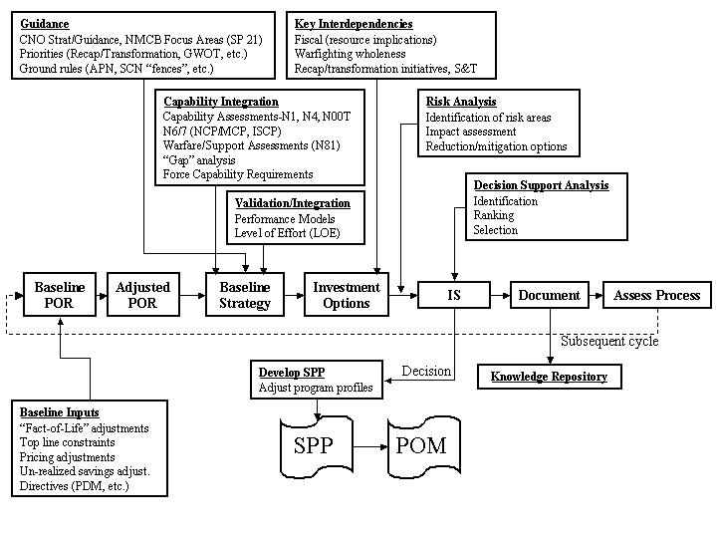

Figure B-12. Development of the CNO’s IS requires analysts with expertise in many disciplines.

Risk Analysis is a critical component of the process including a comprehensive risk examination of external, future, fiscal, and capability risks. Identified risks, will be addressed with reduction/mitigation alternatives. Clear and concise presentation of IS alternatives is essential to facilitate alternative comparisons. Alternative options must be described in terms of fiscal implications, warfighting wholeness, and guidance compliance. Cost components (RDT&E, procurement, operation and support, etc.) must be linked to identify and validate the total cost of the option as completely as possible. Assisting in the alterative comparison will be our state-of-the-art decision analysis tools and methodologies emphasizing collaborative techniques to gain insights, Analytic Hierarchy Process to structure the decision space, math programming to formulate strategies, and a relational database allowing quick information access. When the client decides on an alternative for the IS as the basis of the Programming Guidance leading to the POM it will be with the full confidence that the decision is supported by rigorous analysis, an integrated assessment, clearly displayed priorities and complete knowledge of the horizontal and vertical impacts of schedule or fiscal changes. Documenting decisions and supporting rationale will be captured in the knowledge repository. Our CMMI Level 5 Process Assessment methodology will ensure that process management and product quality are right the first time and will capture process improvements for subsequent cycles

.

B.1.B(3) Deliverable Products and Schedules. [SOW 3.3.3] Deliverable products and schedules specific to efforts associated with the CNO’s Investment Strategy may span the entire set of documentation described in paragraph B.1.F, Reports/Documentation. Specifics about how each of these products and reports are prepared, edited, and delivered are included in that section.

B.1.C. Analysis Support Functions. [L-5.2.1-C][SOW 3.4][M-5.2.1-C] [M-307(c)1.1c]
TEAM-21’s expertise in all phases of analysis support will ensure that all key elements are in

place to support sound, relevant, and defensible Battleforce Capability Assessement and

Programming Process (BCAPP) and CNO’s IS analyses.

B.1.C(1) Scenario Development. [L.5.2.1-C(1)][SOW 3.4.1][M-5.2.1-C(1)] Scenario development is a combination of art and science. Scenarios must be of sufficient detail to facilitate appropriate analyses, be relevant and must be accepted within the Naval and Joint communities. Developing scenarios requires an ability to step away from the status quo, refresh, and then reengage with new ideas that are relevant to the analysis requirements and that build on the Common Frame of Reference and a strong knowledge repository. Without that, scenarios will tend to support system advocates rather than enable independent capability assessments. TEAM-21 has extensive operational experience and analytical expertise in scenario development with OPNAV, HQMC, Joint Staff, and OSD, and has detailed knowledge of key scenario data inputs like Time Phased Force Deployment Data (TPFDD), Logistics Factors File (LFF), Type Unit Characteristics Files (TUCHA), and Non-Nuclear Ordnance Requirements (NNOR). TEAM-21’s broad experience, detailed knowledge, and M&S expertise to develop discriminating scenarios facilitate understanding of how Naval forces contribute to Joint warfighting capabilities. Leveraging and matrixing personnel in the Joint and OSD analytic communities minimizes the potential for non-concurrence of these scenarios and could potentially influence the initial Joint scenario development to better reflect Naval concerns.
(a) Purpose. [SOW 3.4.1.1] DESCRIBE HOW TEAM-21 WILL PROVIDE THE TOOLS NEEDED FOR WARFAER ANALYSES AND IS DEVELOPMENT.

(b) Objectives. [SOW 3.4.1.2] Scenarios will be generated to represent realistic missions and combat situations. Broad spectrums of scenarios will be generated for the analyses to ensure the best alternative is determined under a variety of conditions. Scenarios will be based on the common frame of reference, but the level of detail and scope of each scenario will depend on the specific analysis requirements and the issues being considered. Scenarios will relate back to the DPS through the use of the common frame of reference. The following general criteria for selecting and/or developing scenarios applies: (1) What spectrum of scenarios stresses the Naval capabilities, systems or architecture under analysis and best allows for comparison of alternatives? (2) What mix of study scenarios, initial conditions and assumptions (“least stressful,” “most likely,” “most stressful”) best addresses the spectrum of conflict in the common frame of reference? (3) How can the scenarios cover the scope of operations to accommodate all phases of the campaign or operation from pre-hostilities (and even earlier) on? (4) How can the spread (regional; contingency, unexpected) of threat assessments be folded into the scenarios? (5) What is the appropriate level of scenario detail for the given analysis requirement?

(c) Work Statement. [SOW 3.4.1.3] The process described in Figure B-13 will be used by TEAM-21 to develop and refine the IS. This process addresses the key issues identified for analysis, and uses a constant vetting and feedback process to gain community acceptance and ensure they represent realistic missions and combat situations.

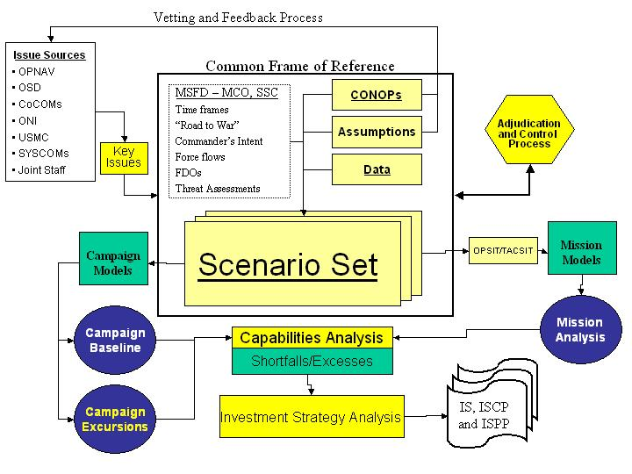
Figure B-13. Scenarios must be developed that are robust in detail to support a variety of analysis.

Scenarios are based on the common frame of reference discussed in Section B.1.A(1), Common Frame of Reference Development, but the level of detail and scope of each scenario depend on the specific analysis requirements and the issues being considered. We track changes to assumptions, and CONOPS to document the lineage back to the DPS or Analytical Agenda scenarios. Broad spectrums of scenarios are generated for analysis to ensure the best alternative is determined under a variety of conditions.

Roundtable discussions with our analytical teams at the NATIC refine the solution space and identify potential weaknesses in the scenario. Given specific analysis requirements, our experience and knowledge is used to identify the key scenario parameters and boundary conditions that drive the results. As a component of scenario development, we conduct war games to refine key elements of the common frame of reference. War games do not have to be elaborate, expensive affairs. Using TEAM-21 Corporate reachback, we can rapidly assemble a team of experts to logically follow a scenario. Employing advanced technology applications like scenario visualization tools resident at the NATIC, facilitators can interactively war game the operation, engage in discussion, group decision-making, and displaying of events. Scenarios are documented, cataloged, and stored in the knowledge repository for general use.
The benefit to this overall approach is to minimize scenario non-concurrence by leveraging industry experts, and comprehensively addressing potential problems BEFORE the analyses are conducted.

B.1.C(2) Development of Capability Characterization Measures (Measures of Performance and Effectiveness - MOPs and MOEs). [M-5.2.1-C(2)][L.5.2.C(2)][SOW 3.4.2]

A hallmark of TEAM-21’s MS&A and wargaming successes has been our ability to identify and capture not only the traditional attrition-based metrics, but also the effects-based metrics that are becoming more relevant to today’s analytical challenges. As an example of our leadership in this area, TEAM-21 wrote and published for OSD: Measuring the Effects of Network-Centric Warfare, Volume One, and Measuring the Effects of Network Centric Warfare; Exploring Belief Metrics in Warfare. TEAM-21 has a wealth of experience developing MOPs and MOEs for a wide variety of customers and is currently performing this work in support of OPNAV, HQMC, Joint Staff, and OSD analyses.

(a) Objective. [SOW 3.4.2.1] As a first step in identifying MOPs/MOEs, or metrics, we will ensure a complete understanding of the analysis requirements and objectives. As Figure B-14shows, metrics can involve technology, including specific system performance; processes that include decision systems, and people accounting for human actions and human-system interface.

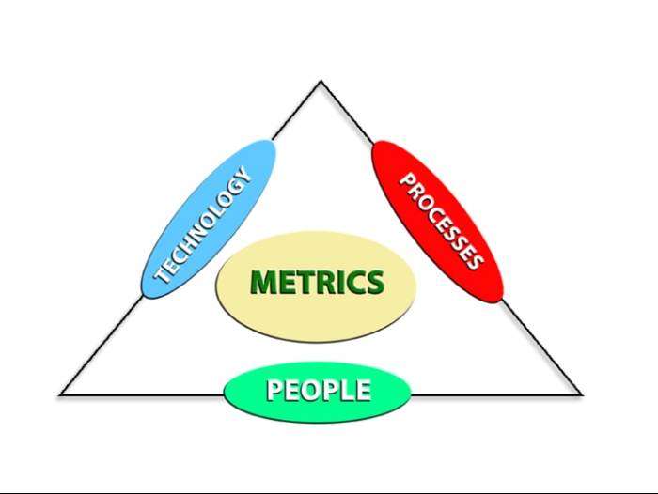
Figure B-14. Developing MOPs, MOEs, and MOOs requires linking people,
technology, and processes to the analysis objective.

We will develop and apply these metrics to the common frame of reference to support the decision framework for effectiveness analysis of alternative systems and architectures. Metrics will be SMART, that is, specific, measurable, actionable, relevant, and timely.

(b) Work Statement. [SOW 3.4.2.2] Metrics will be developed to support not only the evaluation of discrete systems and systems-of-systems, but also to support higher level analyses appropriate to warfare areas and Joint Task Force Commanders. For higher level analyses like campaign analysis, we will tailor MOEs and MOOs (measures of outcome) to the appropriate level of command hierarchy (tactical, operational, strategic). For analyses requiring greater fidelity like mission analysis, we will develop MOPs and MOEs to support the analysis objectives. We will establish “trace back” (hierarchical) architectures to identify key linkages between objectives and measures to enable an understanding of how “supporting” lower level metrics “roll up” to higher level “supported” metrics.

This trace back facilitates the integration of high definition models into campaign analyses, and tailoring to support specific analytical objectives.

Having defined the desired MOPs, MOEs, and MOOs, methods for capturing and determining the feasible range of the values for these measures are determined. Values are obtained through mechanical measurements, derived through observation, or interpreted through a range of data. In some “binary” cases, thresholds establish pass-fail criteria. In other cases, the valuation is only a relative measure. Some effects-based metrics are captured by observing participants in a war game to understand how the decision maker responds to different data. Once the appropriate measures are developed, the selected metrics are applied to either statistically driven modeling to measure the performance of systems and evaluate the influence of different configurations on the measures, or warfighter-in-the-loop modeling to provide insights into the value of the systems to the warfighter.

Our institutional knowledge is leveraged to develop appropriate measures, use the selected measures to test how well a system or architecture performs against alternatives, and document results. The NATIC peer review process ensures the metrics are consistent, enabling realistic comparisons across analyses.

B.1.C (3) Data Base Maintenance and Development. [L.5.2.C (3)][SOW 3.4.3][M-5.2.1-C (3)]

Team-21 has extensive experience ensuring data consistency, capturing authoritative source data, and validating data throughout the broader analytical community. We will leverage this experience to develop and maintain Navy databases for use in warfare analyses and IS development. Our support to the OSD Joint Data Support (JDS) office in designing and developing the JDS data warehouse is an excellent example of our ability to develop and maintain complex databases. Other notable examples include: designed, developed and currently support the Navy’s Program/Budget Information System (PBIS); implemented Internet/SIPRNet-enabled access to the JDS data warehouse, developed the Modernized Integrated Data Base Verification System for DIA, and developed OSD’s (PA&E) Defense Program Projection. Team-21 also maintains state-of-the-art data research and design capabilities within many of its member companies. This capability is available as a “bench” or “reach-back” asset of Team-21.

(a) Objective. [SOW 3.4.3.1] Team-21 will develop and maintain Navy databases to ensure validated, ‘pedigreed’ and accurate data is available in the required format to support required analyses. Our experience with broad-ranging DoD analyses and Navy analytical requirements allows us to forecast data demands and stage the right data before the demand for its analytical use is critical.

Two vital components of the analysis process are researching previous relevant efforts and mining historical data. To assist in this effort, we will develop a knowledge repository using evolving technologies like ‘FAST’, which we used to develop the ‘www.FirstGov.gov’ website. This technology facilitates rapid searching of vast governmental archives, enabling efficient use of analytical resources. We will use this technology in developing the knowledge repository to archive Navy information, results and data so that analysts with appropriate access will be able to quickly locate information and access data through simple keyword searches. At the customer’s discretion this knowledge repository can be web-based with controlled access via the SIPRNET.
(b) Work Statement. [3.4.3.2] Table B-2 summarizes our top-level approach for developing a common set of Navy databases. To best support warfare and IS analyses, TEAM-21 will develop a tailored systems architecture, perform a critical analysis of data elements, and survey the database and model operators to determine the required data elements and input file formats.
As directed by the customer, we will develop controls to manage database permissions and implement client-controlled security protocols.

Common Model Database Development
- Determine Data Requirements
- Research availability of Data
- Develop Data Schema for N81 models
- Evaluate of information and information providers
- Identify alternate information sources
- Determine Primary Source for each item of information
- Peer Review
- Store the data IAW existing configuration management procedures
Table B-2. Steps for Common Database Development
A detailed data schema, developed to address the wide range of data required by Navy analysts and models, will facilitate the creation of a comprehensive database. We will create a common database framework, enabling all models to draw from this database for respective input files. This common framework will be extremely important in supporting transformational M&S initiatives like the Extensible Modeling and Simulation Framework (XMSF).

Team-21 will use the insights gained through developing JDS in identification and development of information/data sources. Information sources will be evaluated to determine the quality of the information in terms of timeliness, accuracy, accessibility, and how often the data or information is updated. The team will make a recommendation for a primary source for each data item. This recommendation will be placed before a peer review panel (i.e. vetted) to agree on the source and value of the data before storing. Data will be stored after it has been verified and validated in accordance with customer-established requirements and DoD Instruction 5000.61 configuration management procedures.

Team-21’s detailed knowledge of and experience with JDS, PBIS, DIA MIDB and the OSD (PA&E) FYDP systems will be a critical factor in the successful development and maintenance of Navy databases. Knowing how each of these authoritative systems are structured enables us to construct Navy databases and data structures capable of rapidly extracting and manipulating data from these systems for use in Navy analyses. Further, the presence of TEAM-21 in JDS gives us an opportunity to ensure Navy and Marine Corps data is used by OSD, the Joint Staff and other services is correct and up to date.

(c) Data Requirements. [SOW 3.4.3.3] The creation of the knowledge repository enables rapid creation of model input files. Our experience is leveraged to use, modify, expand, and interface with existing Navy automated storage and retrieval systems, such as DATATRIEVE and its ORACLE RDB, the Navy Budget Tracking System (NBTS). Our current automated data extraction tools are leveraged and new ones developed to create model ready input files. Whenever possible, TEAM-21 develops input files, which can be directly loaded into the analytical models, eliminating the need to manipulate data prior to ingestion. Our experience in JDS and the SAC is leveraged to modify/maintain/create interfaces between the knowledge repository and both existing and planned models. The team identifies a range of solutions for the interface describing each solution in terms of complexity, cost, ease of use, implementation, data integrity, etc. We assist the Government in evaluating each solution to determine the best course(s) of action to implement both near and long term to deliver required information to N80. Based on the results of the trade-off analysis the team further derives and specifies a living interface that can evolve over time. The team then documents the specification so that all interested parties can build future components to the same specification.

B.1.C(4) M&S Maintenance and Development. [L-5.2.1-C(4)][M-5.2.1-C(4)] [SOW 3.4.4]

TEAM-21 has experienced military analysts and skilled software engineers required to develop and maintain a suite of models to support all levels of warfighting and IS analyses. We have substantial user experience with ITEM, TACWAR, VIC, and EADSIM, (OSD SAC, JASP, DUSA(OR)), have done scenario development coding in GCAM (USMC MAA), and supported the JWARS program office in developing that model. Additionally, we developed Virtual Constellation, which is equivalent to COSMOS and offers additional C4ISR capabilities. We also have experience with logistic and other supporting models such as FORSAT and SEASTATE. TEAM-21 has extensive experience in current programming languages including Visual Basic, C++, FORTRAN, JAVA, HTML, and CMS2 as well as UNIX, LINUX and Windows operating systems. Finally, we can develop or integrate other simulation or spreadsheet models like EXTEND and the Navy Global Calculator model developed by N81.

(a) Objective. [SOW 3.4.4.1] TEAM-21 is experienced with the current N81/N70 primary model toolset and is fully prepared to utilize, expand on, or otherwise modify that toolset as required to develop a standard set of models appropriate for the customer’s needs. Where appropriate, we have federated multiple simulations using the High Level Architecture (HLA) methods. Our experience in model maintenance and development, and our CMMI Level 5 processes will minimize risk of successful completion of the effort. Additionally, TEAM-21 has experience in developing and maintaining a wide variety of modeling and simulation systems used by OPNAV, HQMC, Joint Staff, and OSD. TEAM-21 has been the prime developer for new campaign level models, the strategic lift model MIDAS (Model for the Inter-theater Deployment by Air and Sea), and a detailed C4ISR model, Virtual Constellation.
(b) Work Statement. [3.4.4.2] Table B-3 portrays TEAM-21’s extensive experience with the core suite of models, ranging from campaign to engagement level.
Table B-3. Our team’s model usage and development experience ensure a wide
variety of tools are available to support the OPNAV analyses.

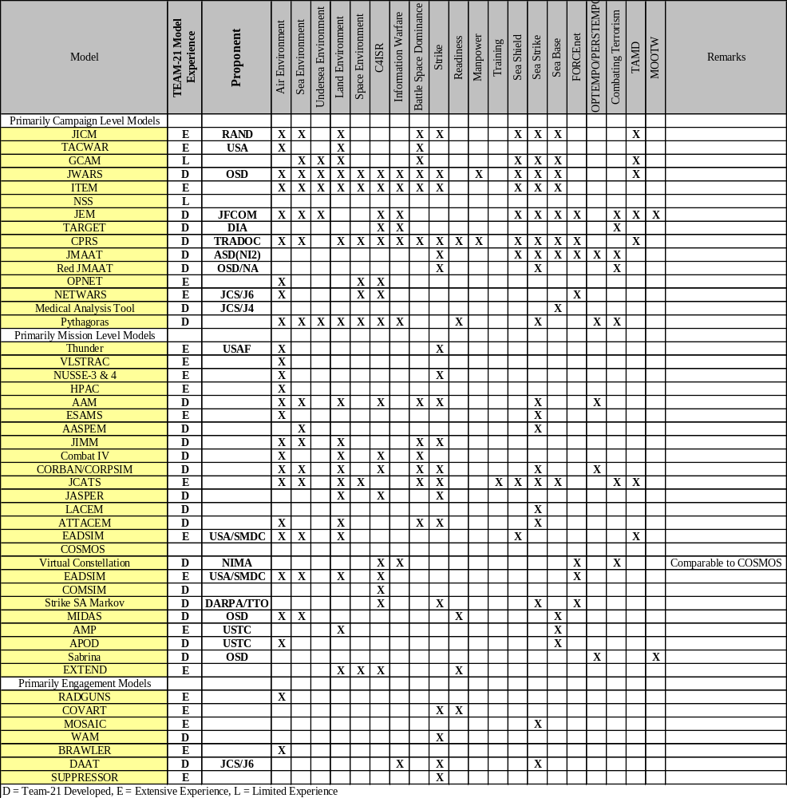

We have listed the primary N81/N70 analytical models, our experience with each, and additional models satisfying niche capabilities and demonstrate the breadth of TEAM-21’s model development and experience. We will assess the strengths and weakness in these models according to the user’s needs, add niche models where appropriate, or provide alternative models as required. This core set of models and simulations identified by N81/N70 will be hosted at the NATIC. TEAM-21 will maintain configuration control compliance for those models not directly under our control and keep an upgrade prioritization list for our internally created models.
In addition to having expertise with each of these separate models, TEAM-21 has experience in integrating models into a federated processing environment. TEAM-21 regularly takes outputs from EADSIM as inputs to Analysis of Mobility Platform (AMP), which affects TACWAR, ITEM, and JICM. Additionally, we have created one of the few successful HLA integrations by developing interfaces between ELIST and MIDAS in the USTRANSCOM’s AMP federation. We will apply these proven methodologies to the suite of models identified by N81/N70. As opportunities for transforming analysis tools and methodologies are developed, like the Extensible Modeling and Simulation Framework (XMSF), we will explore those powerful capabilities and assess the value for use in the N81/N70 M&S environment. Additionally, we will exploit the integrated digital environment through its SIPRNET capabilities at the NATIC to enable distributed analysis with other analytic organizations potentially using HLA or XMSF techniques.

For upgrades to models under TEAM-21 control or for new model development, we will use a variation of Rapid Prototyping Methodology (RPM). RPM has been successfully applied to large and small projects since 1984 emphasizing extensive customer involvement, speed of implementation, and small manageable incremental steps. The approach is both iterative and spiral in nature, as depicted in Figure B-15. RPM, when applied to application development activities, uses a structured, top-down approach to model development. TEAM-21’s CMMI processes ensure thorough QA, documentation, configuration control maintenance across all contractor controlled computer systems. Model verification, validation, and accreditation will be conducted in accordance with DoD Instruction 5000.61 (or as updated by N61M).

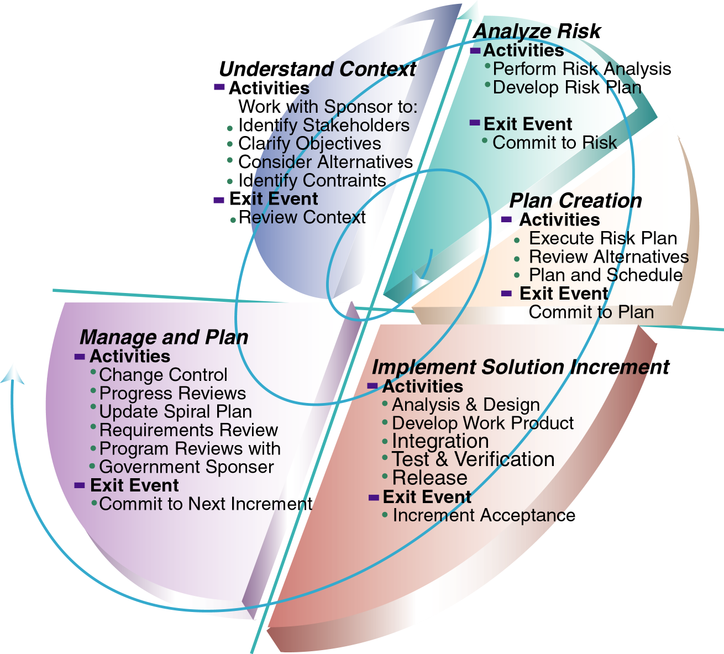
Figure B-15. TEAM-21 will implement a “spiral” approach to model development
to support evolving analytical requirements.

(c) Deliverable Products and Schedule. [SOW 3.4.4.3] Deliverable products and schedules specific to Analysis Support Functions may span the entire set of documentation described in paragraph B.1.F.

B.1.D. Technology Assessments. [L-5.2.1.D][SOW 3.5][M-5.2.1.D][M-307(c)1.1d]
TEAM-21 will survey the analytic research and development community, SYSCOMs and

warfighters, map emerging technologies to identified capability gaps, supporting the Naval

Transformation Roadmap.

TEAM-21 represents a wealth of corporate and personnel experience performing and documenting technology assessments for OPNAV, HQMC, Joint Staff, and OSD. As a team, we bring the methodologies, processes, tools, and quality standards necessary to provide technology assessments that link new technologies to their ability to improve the capability of Naval forces and their contributions to the Joint warfight. Our assessment methodologies have been developed and refined in previous work for the Navy’s Advanced Technology Program (ATP) and current work on the Future Navy Capabilities (FNC) program for ONR and an S&T assessment for N70. TEAM-21 has a strong cost-benefit analysis capability that will support decision-makers in assessing the value of technology enhancements.

B.1.D(1) Purpose. [SOW 3.5.1] A strong S&T program provides options for responding to the range of military challenges. Investment in S&T develops the necessary technology foundation for modernization efforts, discovery of new technologies that produce transformational capabilities, and provides a hedge against future uncertainty. TEAM-21 will provide engineering and analytical support to assess the payback for the Navy’s S&T investments.

B.1.D(2) Defining and documenting methods for transition options. [SOW 3.5.1.1]

We will build on technology assessments currently performed by TEAM-21. Our approach is to identify the required capabilities, proposed S&T projects, and identify capability gaps using a series of surveys. Initially we will survey required technologies/requirements necessary to achieve the SEAPOWER 21 Vision. The second survey will look at S&T projects being pursued by the Navy and Defense acquisition community and industry. The results of these surveys will be entered into the Knowledge Repository using a computerized database management system, such as RequisitePro. The team will identify capability gaps and relevant S&T programs.
We will use the ONR technology readiness level (TRL) appraisal process as a guide to identify both technology maturity and transition to acquisition program leverage points for key technologies that exhibit a high potential warfighting payoff. Elements in the template will include: the technology, the operational performance, maturation timeline, potential transition platforms, costing issues, alternative competitive technologies, and identifying legacy systems being replaced. This approach will ensure that the technologies identified will contribute to naval warfighting needs, allow identification of current and future capability gaps and will also allow appropriate mapping of these technologies into future Naval, Joint, and Allied forces architectures.

B.1.D(3) Performing and documenting technology assessments and forecasts. [SOW 3.5.1.2] TEAM-21’s analytical process flow for technology assessments is shown in Figure B-16.

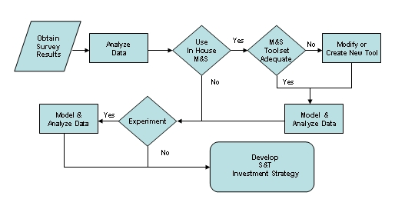
Figure B-16. Our approach makes S&T assessments a component
of the overall warfare and support assessment process.

Analyses of S&T developments will provide a basis for assessing their potential contribution to fill capability gaps. These analyses can take the form of seminars, wargaming, or modeling and simulation. Promising technologies or those identified by the sponsor will be evaluated for further analyses. The TEAM-21 toolset will be evaluated to determine if the existing suite of models can adequately evaluate the technology and its parameters. The key to this analysis will be to identify the value-added capabilities the technologies bring to Naval forces. We will develop metrics to quantify the benefits of the technology, and conduct sensitivity analysis to identify performance “breakpoints.” TEAM-21 will conduct further analysis, as required to develop a roadmap linking S&T projects to system development. Finally, facilitating overall coordination, TEAM-21 will work closely with service related S&T commands and N81/N70.

B.1.D(4) Deliverable Products and Schedules. [SOW 3.5.1.3][M-5.2.1.D][M-307(c)1.1(d)] Deliverable products and schedules specific to efforts associated with the Technology Assessments may span the entire set of documentation described in paragraph B.1.F.

B.1.E. Special Studies and Analyses. [L-5.2.1.E][SOW 3.6][M-5.2.1.E] [M-307(c)1.1(e)]
TEAM-21 will leverage its broad analytical capacity to respond to unique analytical tasking

or quick-turn special studies.

TEAM-21 has the proven ability to quickly organize for and conduct unique tasking and quick turn analysis. Our streamlined management plan, innovative knowledge repository, experienced and highly skilled analysts, corporate reach back, and strong ties to Naval and Joint organizations combine to facilitate expeditious response to unique or short turn analytical tasking. For example, during the PR-05 review process, TEAM-21 performed a quick-turn analysis for the Strike MCP and N70’s Campaign Analysis when additional questions arose about the ability of surface units to defend against swarming small boats.

B.1.E(1) Purpose. [SOW 3.6.1] Special Studies and Analyses, particularly unique tasking, must have a structured process such as that introduced in Section B.1.A (3) that can be tailored to meet unique needs in response to unforeseen events. Our process, shown in Figure B-17, allows us to extend our analytical reach to draw on subject matter experts best qualified to address unique analysis requirements that may need specialized approaches, expertise, or tools.

B.1.E(2) Objective. [SOW 3.6.2] To provide quick response to emergent studies, TEAM-21 will leverage the synergy of our analytic expertise, integrated NATIC, innovative knowledge repository, and extensive corporate reachback. We will streamline and otherwise adjust our methodology to achieve the best results possible given the client’s time constraints.
B.1.E(3) Work Statement. [SOW 3.6.3] The unforeseen nature or urgency of the special study may require non-traditional approaches to meet the analytic tasking. The keys to meeting the assessment needs of special studies are innovative thinking, flexible tools, and established processes. Upon initiation of a special study, the analysis team will leverage the analysis support functions as discussed in paragraph B.1.C already in place.

Figure B-17. TEAM-21’s approach to special studies and analyses is an extension of our overall methodology.

The core models described in paragraph B.1.C (4) will be employed to the maximum extent, but if a new capability is required, TEAM-21 will coordinate with the COR to obtain other Naval/Joint/combined warfare models and simulations, many of which are available through corporate reachback and ties to the broader analytical community. NATIC analysts will be the primary support to meet the needs of the study. The Knowledge Repository will be consulted to find similar studies that can be leveraged. We will meet with the client, agree on the process, schedule, expectations, sources of data, and deliverables to be detailed in technical direction letter from the COR. Periodic update with the customer will be conducted as necessary.

B.1.E(4) Deliverable Products and Schedules. [SOW 3.6.4] Deliverable products and schedules specific to efforts associated with the Special Studies and Analyses may span the entire set of documentation described in paragraph B.1.F.

B.1.F. Reports/Documentation. [SOW 4.0][L-303(a)] The Northrop Grumman IT, Defense Enterprise Solutions (DES) Division has recently been rated under the Software Engineering Institute (SEI) Integrated Capability Maturity Model (CMMI) at Level 5, the highest level achievable. Policies and processes from the DES Process Asset Library (PAL) will be used to provide “best practices” for this contract. This allows TEAM-21 to leverage processes and procedures developed under the guidelines of the CMMI, and helps to ensure quality and standardization across the entire set of documents defined in the following paragraphs. This, in turn, provides the government with assurance that these documents will be more likely to meet their needs, and that the documents will be of the highest caliber. References from other sections of this proposal emphasize that all documentation, reports, briefings and meeting minutes will be handled with the same rigor and following the same tried and proven procedures to ensure quality and timeliness of submission.

B.1.F(1) Contract Progress and Status Reports. [SOW 4.1] In accordance with the solicitation, Progress Reports and Status Reports will be submitted every 30 days beginning 45 days after the date of contract. TEAM-21 will schedule delivery on the same day (15th) of each month. These reports will provide a broad overview of tasks and issues occurring during the reporting period, and information that will allow the COR to validate costs incurred and invoiced as well as the level of effort and deliverables provided during the report period. At a minimum, the monthly reports will include the following:
- The technical direction letter task and subtask number and title.
- A summary of work completed.
- Deliverables scheduled for completion during the reporting period.
- Problems and issues identified during the reporting period and suggested approach to resolve outstanding issues.
- Financial status by task and subtask to include man-hours, amount of dollars expended for labor, travel, and other cost-to-date and projected expenditures.
- Cumulative funds expended, and remaining funds.

B.1.F(2) Model Design Statement. [SOW 4.2] New models, including simulations; tools for analyzing output data; and software applications that are specifically introduced to assist in the decision processes outlined in the SEAPOWER 21 concepts, must be sufficiently documented to make them useful to the analysts that inherit them when they are delivered. The use of flow diagrams and simply presented but comprehensive descriptions of the underlying theory, algorithms, and data requirements are an important part of the model-building process, and one that TEAM-21 has vast experience in providing to our customers. These reports, beginning with conceptual designs and progressing through detailed hardware and software design documents that incorporate hardware selection criteria, software source code language selection criteria, and database requirements, will be provided to the requesting office as drafts for review and approval before software or systems implementation is begun, so that the users can participate in the process of making the tools as robust and applicable as possible.

B.1.F(3) Model Study Report. [SOW 4.3] The solicitation defines the Model Study Report as a document that is a written narrative that describes the methodology for model development prior to writing software code. These documents fit hand-in-hand with the Model Design Documents described in the previous paragraph, and together define the requirements and the implementation of software code that will make the final software application useful as well as efficient, to assist in the analysis process. This document will also describe the environment in which the software will be executed, how the application will share, store, and use data to satisfy the data requirements defined in the model design algorithms. These reports will be provided for comment and acceptance before implementation of software code is begun. These two documents, then, combined with the applicable requirements documents define the development baseline, which will comprise the baseline for the configuration management process with traceable software components throughout the development process.

B.1.F(4) System Specification. [SOW 4.4] The System Specification builds on the Model Study Report, discussed in the previous paragraph, by “specifying” how the integration of the hardware and software are to be accomplished at the time of installation of the application, so that the utility of the software can be optimized. The most important aspect of this document is that it clearly describes the requirements of the environment and how the software exercises the capabilities of the defined suite, so that installers can ensure that the application will function as it was designed. TEAM-21 will provide this documentation in a format and level of simplicity that will ensure installation and integration of delivered software within seven days, as required by the specification of the RFP.

B.1.F(5) Update Models. [SOW 4.5] TEAM-21 will provide these documents in formats that will be presented to the clients for acceptance at the time the technical direction letter or other delivery order vehicle authorizing the work is awarded. The program-wide implementation of our configuration management processes and procedures will provide tailorable documentation formats for “Release Notes”, “Change Proposals”, “Software Configuration Items”, “Peer Reviews”, and other CM tools and processes, which combined will provide a comprehensive record of all aspects of the development and maintenance through the life cycle of the applications built and maintained under this contract.

B.1.F(6) Model/Database Documentation. [SOW 4.6] When existing documents are inherited during the maintenance process, TEAM-21 will ensure that they provide the required level of detail, are accurate within the current functionality of the applicable model or database, and conform to a standard style and level of detail sufficient to make them useful to the intended audience, and so that the documentation provides sufficient depth to enable personnel with one year formal training and two years of experience in programming and automated data processing to understand and run the application. These documents will provide information, at the user level, that has previously been approved through the government’s acceptance of the Design Documents and System Specifications discussed in the earlier paragraphs. They will also include model run test cases as examples in tutorials used for “walking users through the model.” Manuals will be bound in three-ring binders and maintained within the same strict configuration management (CM) processes as the designs and source code. The CM procedures TEAM-21 proposes to use on this program provide for computer program listings to include narrative descriptions of the program functions, input/output parameters, and special features of each Computer Software Configuration Item (CSCI), as well as an internal record of changes, and their impact on the functionality of the module and the overall application.

B.1.F(7) Model Verification and Validation Plans. [SOW 4.7][SOW 3.4.4.2] The key to providing realistic Verification and Validation (V&V) Plans lies in the developer’s ability to initially document the requirements of the system, and then to track the fulfillment of those requirements to the final deliverable. Verification: The process of determining whether or not the products of a given phase of the software development cycle fulfill the requirements established during the previous phase, and Validation: The process of evaluating software at the end of its software development process to ensure compliance with software requirements, requires that the initial documentation, described in paragraphs B.1.F(2) and B.1.F(4), must clearly describe the target deliverable, its mathematical solution set, and the purpose for which each algorithm, interaction, and outcome is to be examined. This process ensures that the software system will perform to the customer’s expectations under operational conditions. TEAM-21 will tailor V&V Plans using our CMMI Level 5 PAL in coordination with the government customer to ensure that the steps accomplished in the process will meet those expectations, and that the steps in the process will, in the minds of the customers, reflect this accomplishment. The V&V Plans will be developed in accordance with DoD Instruction 5000.61 for models created, updated, or modified under this contract. A written description of these plans will be provided as specified in each technical direction letter (TDL) authorizing the work to be performed.

B.1.F(8) Code. [SOW 4.8] For all models developed, maintained, or updated under this contract, the source code will be provided to the government whenever, throughout the development cycle, the government requests delivery. TEAM-21 will coordinate deliveries of recompilable source code to coincide with the availability of a complete set of documentation that fully describes the CSCI and that provides a completely defined and implemented functionality within the CM process.

B.1.F(9) POA&M Report. [SOW 4.9] Upon receipt of each TDL, TEAM-21 will prepare a Plan of Action and Milestones (POA&M) Report as part of the initial planning process, detailing the schedule of milestones and deliverables for the specific task. This POA&M Report will be updated as changes to the technical direction letter occur.

B.1.F(10) Technical Direction Progress Report. [SOW 4.10] According to the solicitation, Technical Direction Progress Reports may be required specifically with respect to each TDL issued, at a frequency specified by the COR. We will provide these reports as part of the Contract Progress and Status Reports discussed in paragraph B.1.F(1). When additional requirements are specified in the TDL issued for a specific task, the required reports will be provided and the information contained in those reports will be included in the monthly Contract Progress and Status Report that is issued immediately following the due date of the specified report.

B.1.F(11) Final Report. [SOW 4.11] Upon completion of the work described in each TDL, TEAM-21 will provide a Final Technical Report detailing the goals of the effort, the conduct of the technical direction, the conclusions reached, and recommendations for follow-on studies or analyses. At a minimum, these reports will summarize all information provided in the Contract Progress and Status Reports, provided during the life of the technical letter that is being completed.

B.1.F(12) Technical Briefs. [SOW 4.12] Occasionally, it will be necessary to prepare progress and final technical brief viewgraphs, handouts, or electronic copies summarizing the goals, conduct, conclusions, and recommendations relating to the status of performance for each TDL. These briefings will be prepared to convey ideas, goals, objectives, results, and recommendations as appropriate to keep the government informed between periodic Contract Progress and Status Reports, and when feedback will assist TEAM-21 personnel in the accomplishment of specific tasks. Such briefings may be directed by the COR to fulfill specific goals and objectives of the TDL. Formal delivery of these reports will be as attachments to the Contract Progress and Status Reports delivered monthly, following the presentation for which they were produced. Corrections and comments provided during the presentations will be the subject of a section of the Contract Progress and Status Reports to which the briefings are attached.

B.1.F(13) Meeting Minutes. [SOW 4.13] When requested by the COR, TEAM-21 will provide minutes of meetings held to review goals and objectives of the supported clients. These meetings will include, but not be limited to technical exchanges, study progress reviews, interim progress reviews for technical letter assignments, and periodic discussions of ongoing activities. The documentation of meetings will include at a minimum, the date, time, and location of the meeting, a list of attendees, the purpose of the meeting, identification of key points and issues raised and resolved during the meeting, and a summary of conclusions and accomplishments made during the meeting. These minutes will be preserved for use and reference during future meetings.

B.1.F(14) Deliverable Products and Schedule. [SOW 4.14][L-319] As required by the SOW and section L of the RFP, TEAM-21 will be prepared to submit all contract data requirements in digital format (e.g.,3.5” floppy disk, zip diskette, or accessible on-line through Web connectivity). TEAM-21 will comply with or tailor government specifications for software development using Northrop Grumman IT’s newly certified CMMI-Level-5 Processes and Procedures where appropriate, to simplify document preparation and submission. All documents and deliverables described in paragraph B.1.F, Reports/Documentation, will be delivered to PMW-153 with copies to the OPNAV code(s) as specified in the technical direction letter of assignment authorizing the work performed. The Program Manager will keep copies of all contract deliverables to assure CM procedures and quality assurance (QA) processes are continuously monitored and that deliverables are provided to the government in a timely and accurate manner.

B.1.G. Other Tasks/Reports. [SOW 5.0] TEAM-21’s Program Manager will comply with all terms and conditions in accordance with the technical direction clause contained in Section H of the solicitation.

B.2. Sample Tasks. [L-5.2.2][M-5.2.2][M-307(c)-1.2]

The following sample tasks illustrate the breadth of TEAM-21’s analytical capabilities. The

first example demonstrates an innovative approach to a classical analytical problem. The

second example highlights our ability to meet emerging analytical challenges using innovative

thinking, tools, and methodologies.

B.2.A. Expeditionary Assault Group (EAG) Analytic Baseline – Force Structure Task.
[M-5.2.2][ [M-307(c)-1.2][L-5.2.2][3 Pages]
The five requirements for this task provide the framework for EAG force structure analysis.
1. Develop analytic baseline for evaluation of EAG capabilities. The analytic baseline is the approach and methodology we employ in evaluating EAG capabilities. Consistent with the client’s needs, we frame the analysis, select the metrics, tools, and techniques and perform capability, gap, and tradespace analysis. We adjust our methodology to the client’s time and fidelity requirements. We identify data requirements and candidate sources for that data, characterize future systems or new capabilities, and, as necessary, use surrogate metrics. War games and distributed analysis are components of the modeling and simulation process that capture cognitive issues and warfighter inputs in an iterative process to assess EAG capabilities. We use multiple time horizons supporting legacy and planned capability analysis.
2. Develop baseline analysis case and assessment for an EAG or multiple EAG operation supported by other forward deployed naval and joint forces. The baseline capability defines the force mix to be assessed. If not provided, we develop alternate EAG platform and system mixes, with client approval. We conduct a preliminary analysis with one EAG (nominal mix includes ‘L’ class ships, SSN, multiple DDGs, CG, and an organic airborne ISR capability) against a postulated threat to determine capability “breakpoints.” OPSITs are evaluated for breakpoints in each SEAPOWER 21 pillar to determine their inherent capabilities. Excursions examine a mix of EAGs and other sea/land based joint/Naval assets and manned/unmanned platforms. Analysis of EAG performance in five scenario OPSITs (below) supports force structure recommendations.
3. Identify a specific operation of interest. For illustrative purposes, an EAG is forward deployed as a “show of force” and to monitor the deteriorating internal situation in CITAN, a small and remote littoral nation with a pro-U.S. government. Additional tasking is anticipated to stabilize CITAN’s decaying internal situation, or to intervene in small-scale destabilizing actions by neighboring anti-U.S. countries. DIA’s threat assessment for neighboring countries is “low to moderate” (two diesel submarines, mining capability, swarming small boats using Boghammer-type SSCM platforms, and limited near-land TACAIR capability), and anti-access actions must be anticipated by the EAG.
4. Develop a high level definition for the analysis case. This definition includes a scenario and representative OPSITs. CITAN has a major transshipment port for natural gas. CITAN’s president, viewed as being too pro-U.S. by a vocal minority, has experienced declining political-military support. The military leadership’s allegiance is suspect, as cross-border raids and threats against the regime and U.S. businesses have gone unchallenged. There are unconfirmed reports of third-party actors smuggling chemical weapon precursors through CITAN. Representative OPSITs focus on EAG capabilities for a range of tasking and threat conditions. Situation Awareness OPSIT: The EAG must use its organic ISR capability to monitor air, subsurface, and surface activity around the EAG, port, and border crossings. Areas suspected of concealing chemical weapons material are of high interest. Global Hawk/BAMS support is not continuous so the EAG uses its organic UAV, covertly inserted Marine RECON elements, the SSN for in-close port surveillance, and communications with the local consulate and failing government. Interdiction OPSIT: Neighboring army units are detected by EAG assets crossing unopposed into CITAN. The EAG is tasked to track these forces, determine their intentions, and prepare to halt their advance. Secure CW Material OPSIT: COMINT intercepts and recon unit reports indicate an unknown group may be moving chemical weapons material to the port for shipment to a known terrorist organization. Due to CITAN’s increasingly chaotic situation, the EAG is ordered to interdict and secure the CW material, and exploit any intelligence opportunity regarding the group’s operations. EAG forces should expect armed opposition from the group. Battlespace Control OPSIT: The EAG must defend against the small but multi-dimensional and escalating threats from adjacent countries as defined in requirement #3 above. Each OPSIT is assessed independently and then integrated with other OPSITs in a comprehensive analysis to stress EAG resources.

5. Develop analysis case using a Modeling and Simulation tool set. The choice of tools is determined by the study requirements and client’s needs. In this case, we recommend EBW/NSS for complementary effects and attrition-based force interaction details, AAM for expeditionary operations, Virtual Constellation/NSS for C4ISR, Extend for logistic analysis, and theater-level deterministic models and simulations like ITEM, Combat IV, or GCAM for analytic baselines and interactions. These tools provide end-to-end analysis capturing the capabilities of the EAG in the OPSITs, exploring alternate EAG configurations, and conducting performance excursions as supporting forces are introduced or threat levels changes. Tools like Pythagoras provide a quick-look “aggregate up” view. Ultimately, the capability analysis supports cost-performance trade analysis and becomes part of the investment strategy. The estimated labor mix and hours follow:
Labor Category | PM/PE | SE | SA | AE | CP | Tech Ed | Admin Asst
Hours | 32 | 160 | 640 | 640 | 320 | 16 | 8

B.2.B What is the value of data from an endurance UAV (e.g., BAMS) in enabling effects-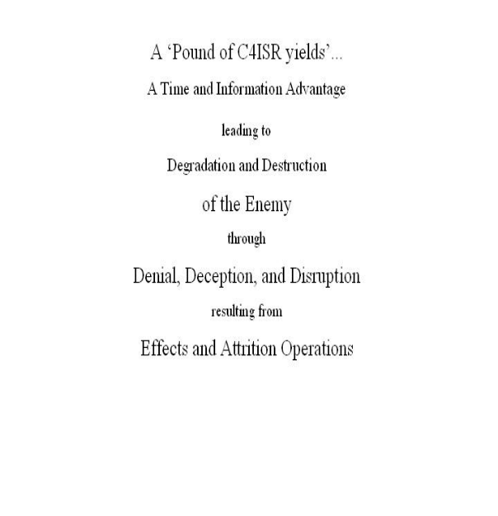based operations? [M-5.2.2][ [M-307-#1.2][ [L5.2.2] The U.S. Navy and the DoD are embarked on a transformation of missions, competencies, composition, and force organization accompanied by effects-based concepts that are qualitatively different from attrition analysis focused on platforms and weapons. In a Network Centric Warfare (NCW) world capturing the rich, dynamic, information-driven complexity of modern warfare, requires an effects-based modeling, simulation, and analysis methodology. We use results of experimentation as a component in our analysis to assist in understanding the contribution of NCW-enabling technologies and systems such as BAMS UAV. Timely and accurate information generated by and provided through a fully integrated architecture enables effects-based operations as shown in Figure-xx. Our federated modeling approach allows us to understand the ‘how and why’ of an architecture’s performance including the new tactics and capability enabled by NCW. When coupled with effects metrics and capability objectives we generate significant insight into the benefits of NCW.

Methodology. Our approach allows us to answer “How will data from a long endurance UAV help the commander employ his Information Operations resources before hostilities and during conflict to achieve the maximum effect?” in addition to answering attrition questions such as “What is the improvement in the probability of kill as a result of BAMS data?”

We capture the results of effects-based operations in our modeling, simulation and analysis methodology. Our effects metrics gauge the impact of the Commander’s actions on the enemy’s beliefs and reasoning.

We conduct a preliminary scenario analysis using the Strike Situation Awareness Markov model: a fast, low fidelity, broad scope, probabilistic model to explore the UAV’s parameter space to identify high payoff CONOPS and collection strategies. Physical metrics such as area coverage, ability to detect targets by the respective sensors, the ability to downlink, process, and disseminate data, the improvement in aim point development, and the resultant change in kill performance are representative for this analysis phase. The high payoff CONOPS and collection strategies explored by a federation of high resolution discrete event models to capture “cause and effect” across the architecture, using for example, OPNET or NETWARS for communications; Virtual Constellation for ISR tasking, data collection, and exploitation; and DAAT and JSAF for the strike mission using analysis threats and scenarios.

To fully capture the effects of information on Blue and Red decision processes and force utilization, we use models and methods involving human-in-the-loop processing and analysis to measure the end-to-end architecture performance. Our analysis team, which has relevant experience as decision makers and warfighters, assists in capturing the impact of information on stakeholders in a war game (e.g., OPNAV, NWDC, and Fleet representatives) exploring how warfighters might use UAV data to create impact. The Integrated Gaming System (IGS) using the Entropy Based Warfare model establishes the framework for the war game and captures the results of denial, deception, and disruption actions on the enemy’s beliefs and reasoning based on the information advantage resulting from UAV data. These results manifest themselves in changes in the enemy’s force deployment/utilization. Figure B-18 shows the IGS framework that supports the wargame exploring how different technologies and CONOPS affect Blue and Red decision processes and improve Blue intelligence preparation of the battle space. Results from the war game analysis contribute to the acquisition decision processes, CONOP development, and system employment.

Figure B-18. Our process combines the strengths of multiple approaches.

Summary: Taken together, the use of experimentation, wargaming, and the federated approach to effects-based modeling represent a transformation of analysis. Transforming to NCO requires an effects-based complement to our clear attrition superiority, as evidenced by recent events. We have used our weapons to kill the enemy and deny him his sensors, command and control. Regardless of how we defeat the enemy, whether by disruption of his organization and combat structure, or by attrition, we need to be able to assess the resulting effects on his beliefs and reasoning. Our methodology, based on experience, provides a capability to establish clear cause and effect relationships between NCW and defeat of modern adversaries. The table below identifies the labor categories, hours and travel for this four-month analysis.
Labor Category | PM/PE | SE | SA | AE | CP
Hours | 68 | 680 | 1360 | 1360 | 680
Travel: 2-week trip to FLEETEX site for data collection/observation of exercise (2 people)

Personnel Experience. [M-5.3][M-307(c)-2][L5.3]

All personnel proposed in support of this Program meet the minimum RFP requirements.

Most have experience and levels of education that significantly surpass the minimum

requirements. Resumes are provided in this proposal for all personnel listed.

C.1. Managerial and Key Personnel Listing. [L-324(b)(5)] The following table lists the names, positions, and level of security clearances for liaison and contract management personnel proposed to support TEAM-21’s technical approach. These individuals are proposed as “Key” personnel and will be available within 15 days following the award of the contract resulting from this procurement. Resumes for the personnel listed in the table are included in the resumes submitted with this proposal.
Table C-1. Names and Positions of Key Personnel for Liaison and Contract Management [M-3c]

NAME | Position/Function | Team Member | Security Clearance
Dennis Baer | Program Manager/  Contract Management | Northrop Grumman IT | TS
Daniel Schluckebier | Principal Engineer/  Technical Management | Northrop Grumman IT | TS
Mike Albright | Principal Engineer/  Technical Management | Northrop Grumman IT | Secret
Lee Dick | Principal Engineer/  Technical Management | Office 21 | Secret
John Draper | Principal Engineer/  Technical Management | Booz Allen | TS
David Lee | Principal Engineer/  Technical Management | WBB | TS

C.2. Personnel Available for Temporary Assignment. [L-324(b)(4)] Current employees that are available on a temporary basis to provide special qualifications or part-time support for TEAM-21’s quick reaction capability are listed in paragraphs D.1.D(2) and D.2.A(2).
C.3. Personnel Resume Requirements. [L-345] A description of the education and experience desired for each labor category is compared to Northrop Grumman labor categories in Table C-2.

Table C-2. Northrop Grumman Labor Category Experience and Description

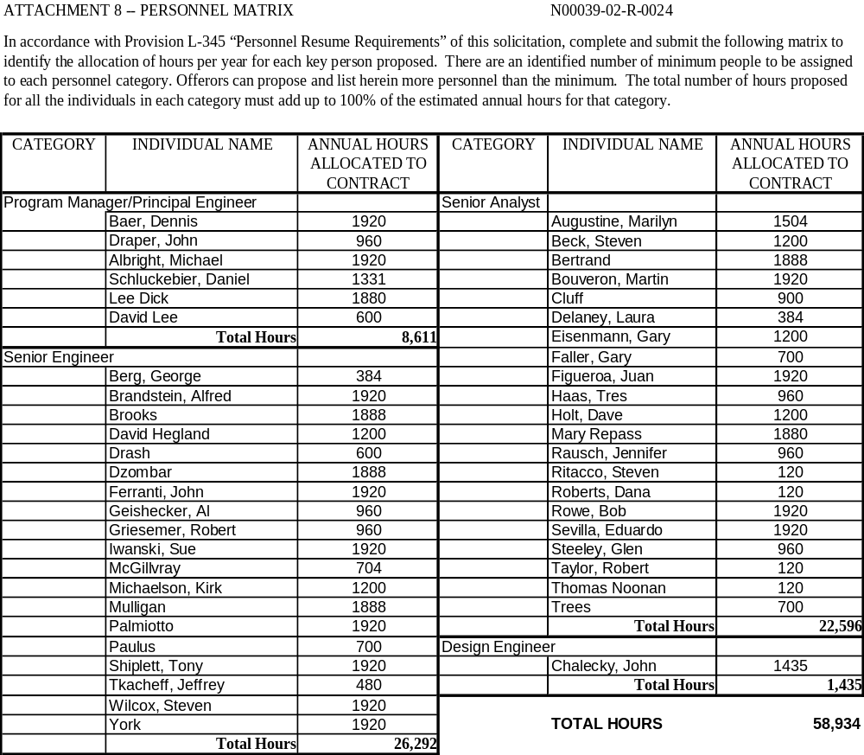
Table C-1 Attachment 8 - Personnel Matrix for Key Personnel

Management Approach. [L-5.4] [M-5.4] [M-4(b)] [L-324(b1)] [L-324(b2)][L-324(b6)]

TEAM-21 will provide the government the best talent for individual task orders at the most

economical cost. We provide the total capability within the TEAM-21 contractor set to

fulfill all of OPNAV's Modeling, Simulation, and Analysis needs.

Our integrated management philosophy for TEAM-21 is shown in Figure D-1. TEAM-21 is very low-risk for transitioning from incumbents and successfully managing MS&A contracts of this size and scope or larger (Joint Analytical Support Program -JASP.) Our corporation is CMMI Level 5, which provides certification to our customers that TEAM-21 has established and proven management processes resulting in increased quality, continuous process improvement to reduce the level of effort (cost) and minimal government oversight.

TEAM-21 not only accepts the conflict of interest clause in the solicitation, but also has examples of many projects within DoD of similar scope, where OCI mitigation plans were conducted successfully within the Department of the Navy. A sample OCI Risk Mitigation plan is submitted with Volume III. These OCI mitigation Plans include the USMC, Mission Area Analysis; USMC, Aviation Transition Support; and the USMC, Studies Program.

The focus of this management approach is that the Government will have a single point of contact for technical and contractual management execution. TEAM-21 will appear to the client as a single team with the burden of managing multiple contractors fully absorbed within our approach. However, technical flow of information will be strongly encouraged between the government stakeholders, Navy/USMC staffs, and TEAM-21’s technical, analytical, and computer-related staff.
D.1. Organization, Staffing, and Management Plan. [L-324(b)(1)][L-5.4(1)][M-5.4.A)][M-307-(c)][M-308] TEAM-21 is organized, staffed, and managed as shown in Figure D-1. A sample work structure chart by job classification relative to the SOW sections is provided in Table D-1Table D-2, below. The benefit of TEAM-21 is that the right mix of experienced and highly skilled experts and novice analysts has been assembled to be both cost-effective and innovative. Our senior analysts will provide a mentoring leader-follower atmosphere, which will allow junior analysts to assume the roles of the more senior analysts as the contract evolves, reducing costs in the out years. The NATIC will allow group dynamics, provide synergy by replicating the successful model within OSD (PA&E)’s Simulation Analysis Center (SAC), currently being employed by several of the TEAM-21 teammates. This concept is low-risk and representative of the Team’s corporate cultures.
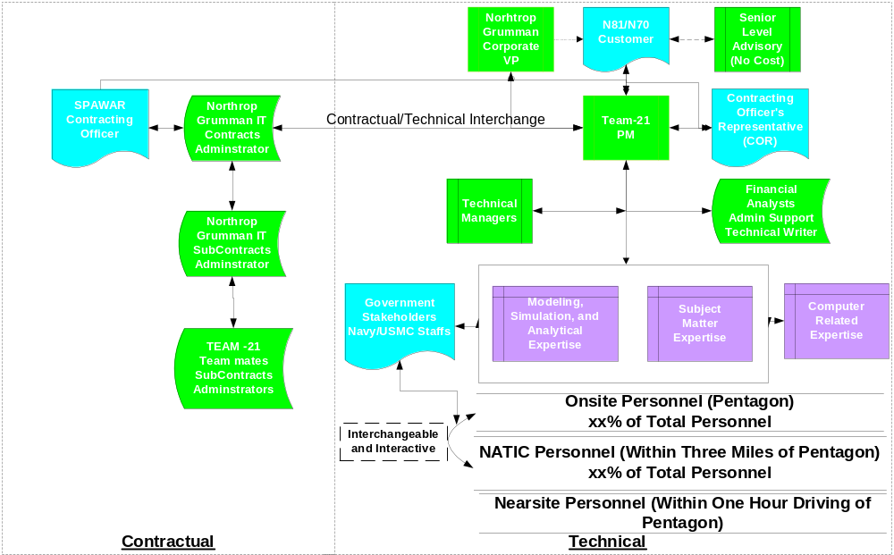.
Figure D-1. TEAM-21 integrated management approach.

Table D-2. Single management approach allows focus on SOW tasks. [M.5.4.A(1)]

Management/Support |  |  | Technical/Analytical |  |  | Computer Related
Category | % Time Relative  to SOW |  | Category | % Time Relative  to SOW |  | Category | % Time Relative  to SOW
Program Manager  Principal Engineer | 70 |  | Sr. Research  Specialist | 95 |  | Design Engineer | 95
Financial Analyst | 0 |  | Sr. Engineer | 95 |  | Computer System  Analyst | 95
Technical Writer | 95 |  | Senior Analyst | 95 |  | Computer Programmer | 95
Administrative Support | 95 |  | Associate Engineer | 90 |  | Technician | 95
 |  |  | Associate Analyst | 90

The Program Managers/Principal Engineers were selected for their extensive experience in N81/N70, established leadership within the analytical community, and proven program management skills of DoD MS&A projects. To preclude any “perceived” additional cost of oversight, all managers will be working analysts.
Mr. Dennis Baer has been selected as the Program Manager (PM) of TEAM-21 for his demonstrated leadership in the Naval analytical community. As a past president of the Military Operations Research Society, with previous tours in N81 and Naval Center for Analysis, and Senior Manager of Navy Programs within Northrop Grumman IT’s Modeling, Simulation, and Analysis Center, he is highly qualified to lead TEAM-21. As a Senior Program Manager, he will be a direct report to Dr. Bill Lese, a corporate Vice President, who has the authority to direct assets to meet any requirements established of this project. Dr. Lese is a retired SES from OSD (PA&E) and considered an expert within the DoD MS&A community.
TEAM-21 is dedicated to meet all financial, personnel, and human resources requirements set forth in this solicitation. No uncompensated overtime will be used during the performance of this contract. [M.308] TEAM-21’s Corporate Training Programs ensures our staff maintains the state of art professional qualifications. Our CMMI-Level 5 certification ensures that TEAM-21 will successfully manage all technical tasks effectively and economically. Section D.1D(1) provides the details on how this will be performed.
The proposed organization, to include our teammates, has the required technical, contractual, and personnel assets [M.5.4.A] necessary to meet or exceed all solicitation requirements. This is substantiated in Sections B, C, and E, and Volume II, Cost Proposal.

D.1.A. Transition Plan. [L-324(b)(6)] TEAM-21 will provide a well thought out and seamless transition that is low risk to the Government. TEAM-21 has the capability and capacity to assume complete responsibility within 15 days from contract award for providing all services accomplished under this solicitation.

Northrop Grumman IT, as prime, will leverage its recent successful JASP contract transition from an incumbent. Mr. Dan Schluckebier, former JASP Personnel Transition Coordinator with N-81 experience, will be the TEAM-21 transition coordinator and assume Technical Lead of the NATIC. Mr. Mike Albright, currently supporting N816 for the previous year, will assist in the Technical Transition, and assume duties as the Onsite coordinator. TEAM-21 will use personnel who are highly experienced in the OPNAV assessment processes, as well as personnel currently supporting OPNAV to help in the transition process.
The singular purpose of TEAM-21’s transition plan is to ensure we are ready to support our clients in a timely manner. The Transition Team will be formed to guide that effort and will be prepared to begin coordinating with key government personnel immediately upon contract award. A primary product of this interface is the establishment of early and continuing customer confidence in the capability of TEAM-21 to accomplish all tasks incident to the contract. Initially, the Transition Team will concentrate on the following areas:
- Establish contracts/administrative interfaces
- Approval of an OCI Mitigation Plan
- Establish operational and technical interfaces with key government personnel
- Establish staffing plan and coordinate Transition Training Plan with government
- Establish interface with incumbent’s transition management
- “Observe and shadow” work in progress and develop plan to assume
- Inventory and turnover of GFE
To the maximum extent possible, all “spool-up” will be done in advance of the start work date. Upon contract award, we will begin configuring the NATIC with the people, processes and contractor-owned hardware/software required to support/continue the assessment work in progress and work expected to be done in the first several months after start work date. Upon direction of the government, turnover of GFE will be effected in a gradual, organized manner so that all government-owned databases, tools and other resources are transitioned to TEAM-21 and verified as being “operational” so that the NATIC is “up and running” with the right people, tools and processes prior to the start work date. We will consult with key government personnel to determine the requirements of the next 3-6 months and begin setting up those capabilities in the NATIC. As soon as possible after the start work date, we will begin looking at the requirements of the next 6-12 months to determine what capabilities we will need to be put in place.
D.1.B Procedures for determining in-house, subcontractor, joint effort. [L5.4(1)(a)] For each task assigned, TEAM-21 will implement the process shown in Figure D-3 to determine how the team will support the effort. The focus of this process is accomplishment of the primary goal of TEAM-21: to provide the most qualified support personnel for each task, regardless of company affiliation. The TEAM-21 selection portion shown in blue will be accomplished within 24 to 48 hours, ensures no “perceived” OCIs occur, and all teammates will receive work. If there are “perceived OCIs” from the Government of any teammate based on the subject material of that task, that teammate will be excluded from task execution. To be an “Honest Broker”, Northrop Grumman’s IT sector will construct the necessary firewalls to execute this solicitation.

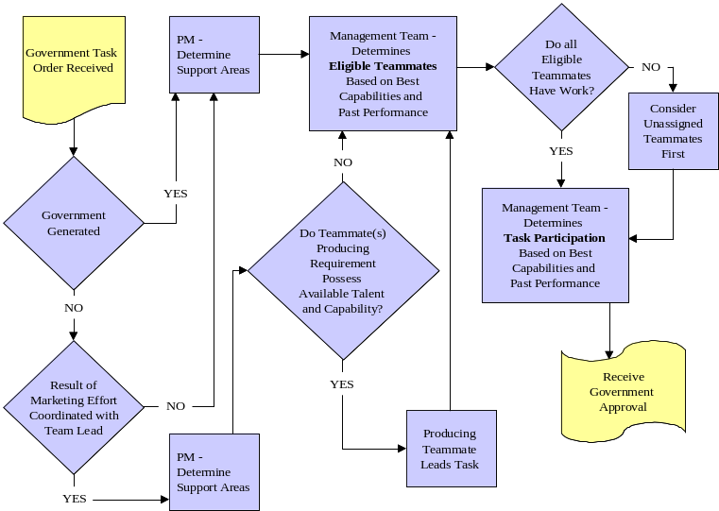

Figure D-3. TEAM-21 Support Personnel Selection Process ensures high quality, agility, and timeliness.

D.1.C. Role and Authority of Offeror’s Subcontractor(s) Program Managers. [L5.4(1.b)] Subcontractors PMs are responsible to their corporation for all matters concerning their personnel. They also will assume technical lead on selected task orders and report directly to the TEAM-21 Program Manager and Technical Managers (PM/TMs). Direct contact will be permitted with the customer and will be coordinated with the PM/TMs.

D.1.D. Procedures for ensuring that deliverables are technically accurate, timely, complete, and prepared in the proper format. [L5.4(1.c)][M-307(c)-3.1a]

Northrop Grumman IT is a long-established government contractor with tried and proven standard operating procedures that have been used successfully to ensure that the quality and timeliness of deliverables are always foremost in the minds of those responsible for their production. Three levels of attention within TEAM-21 support these standards. (1) Processes and procedures used to support this program within Northrop Grumman IT’s Defense Enterprise Solutions have been verified under the CMMI at Level 5. CMMI Level 5 affords a comprehensive structure of management and program guidelines and responsibilities emphasizing the repeatability of our efforts to ensure that our goals for high quality and timeliness of deliverables are attainable and accomplished in every instance. This will enable a focus on the accomplishment of the tasks and not on the implementation of new processes and procedures. (2) Our Quality Assurance (QA) Plan is a standardized proven process that is implemented to consistently stress the importance of quality in our deliverables, beginning with the technical staff assigned to any task awarded, and contiguous throughout the corporation up to the senior corporate management level. A summary of the QA Plan for this effort follows in paragraph D.1.D(1). (3) The team members and management staff available and assigned to support this effort have been selected for their experience and successes in providing quality products on similar assignments and tasks throughout long and recognized careers.
D.1.D(1) Quality Assurance (QA) Plan. [L5.4(1.c)] TEAM-21’s technical and administrative personnel are periodically refreshed concerning the importance of quality products and in the necessity to ensure the QA processes and procedures are kept foremost in the minds of those who author and publish deliverable documents. Our process improvement program requires all processes and procedures are continuously evaluated and enhanced when new and innovative methodologies are discovered. Technical Task Managers serve as the managers of staff personnel performing on specific tasks and as peer reviewers. Typically these managers will perform and hold qualifications at the program manager/principal engineer level or at least at the senior technical level described in the RFP (L-5.3.Section C). They will provide guidance, direction, and supervision for task performance and will keep the PM advised on the current status, deliverables, and client requirements within their area of cognizance. Task Managers are the first line of QA, and as such are responsible for the quality and timeliness of all deliverables and support applicable to their task(s). Task Managers will provide frequent interface with N81 and N70 technical managers (and task monitors) and ensure the timely and accurate accomplishment of every subtask assigned. Program management personnel, including technical task managers, program managers, and corporate level managers, are guided by published policies, processes, and procedures that map duties to the management structure, and assign quality assessment responsibilities not only for deliverables to clients, but to the QA function within the company. Figure D-4 summarizes the approach implemented in support of this contract to maintain enhanced quality services. The QA process begins before tasks are received, during implementation of the processes and procedures that govern the methodology. The key to ensuring the standards are consistently met is TEAM-21’s attention to ensuring that all personnel understand and are able to perform the processes that enable this achievement throughout the assessment of tasks, the planning of how these tasks will be performed, and the execution of the specified plans.

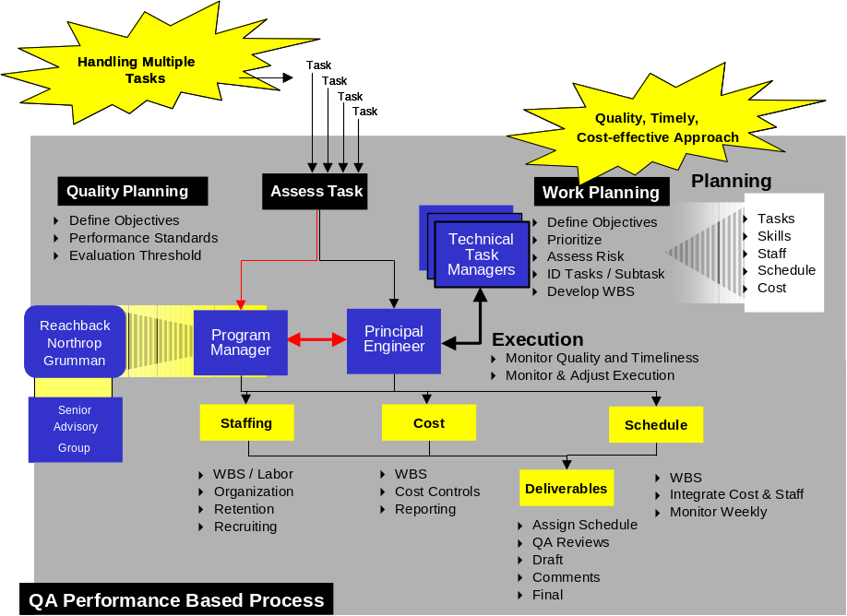
Figure D-4. Our QA performance based process ensures timely delivery of all products.

D.1.E. Subcontracts. [L5.4(1.d)] TEAM-21 has been formed to provide the comprehensive expertise required to satisfy the diverse needs of N81 and N70 through a unified team, managed as a single point of support, so that our clients are spared the excessive effort of managing multiple contracts.

D.1.E(1) (Subcontractor) Management Plan. [L5.4(1di)] Northrop Grumman IT will handle all subcontracts administration. A subcontracts administrator will be permanently assigned on this contract and report to the TEAM-21 Program Manager and Contracts Administrator. All technical and personnel matters will be handled by the individual subcontractor technical leads, who will report directly to the Program Manager and these actions will be transparent to the Government.

Northrop Grumman IT has always maintained strong small business goals and this contract will be no exception. We participate in the Mentor Protégé program, which assists the Small Businesses in obtaining qualifications and growth to be competitive. Our small business goals are described in Volume II, Cost Proposal, and Volume III, Contractual. The Small Business Goal is 35% of subcontractor revenue, and Small Disadvantaged Business Goal is 15% of subcontractor revenue.

D.1.E(2) Organizational Structure. [L5.4(1dii)] TEAM-21’s subcontractor organization is shown in Figure D-1, above, and explained in Section D.1.E(1). All subcontractor transactions cost centers are treated by (add description). The identification of key personnel dealing with Contracts is provided in Section C, and resumes in Appendix A.

D.1.E(3 Reporting Control Procedures. [L5.4(1diii)] The contractual and technical reporting control procedure is described in Section D.1.E.1. All financial reporting will be directly to the Program Manager, with assistance from the TEAM-21 Financial Analyst.

D.1.E(4) Subcontractor’s Past Performance. [L5.4(1div)] All subcontractor past performance and corporate experience is provided in Section E.
D.1.F Subcontractor’s Selection Criteria. [L5.4(1e)] All teammates on TEAM-21 were selected for their excellence in DoD analysis (AT&T, EDO), with emphasis on their superior N81/N70 performance (BAH and WB&B), strong consideration towards meeting our Small Business Goals (TAG-LLC, O21, Gryphon Technologies, and Red Pen, Inc.), and their capability to work together as a fully integrated team.

D.1.G. Management Control for Subcontractors. [L5.4(1f)] This procedure is described organizationally in Section D.1.E(1), the selection process for each task in Section D.1.B, and the Quality Assurance aspects in Section D.1.D(1).

D.1.H. Single Facility Integrated Team. [L5.4(1-g)] A majority of TEAM-21 (including subcontractors) will be located either onsite or at the Naval Analysis TEAM-21 Analytical Cell (NATIC) described in B.1.B(3). The Pentagon Onsite Coordinator (Task Manager) will be Mr. Mike Albright, and the NATIC Coordinator will be Mr. Dan Schluckebier. Each task will have a Technical Lead assigned, but the number of Task Managers has been greatly reduced due to the integrated facility.

D.1.I. Government-Furnished Property.[L-501] TEAM-21 agrees that government-furnished items, such as computer hardware, software applications, and data will be provided only as described in Delivery Orders or technical direction letters. Reference to such required items will be made in TEAM-21 proposals in response to all tasking, prior to commencement of the work required.
D.2 Quick Reaction Capability. [L5.4(2)] [M5.4B] [M-307©3b] Our innovative technical approach coupled with our integrated management approach is designed to handle quick reaction capability due to the integration of the right people, with the right knowledge, to use the right tools and processes.
D.2 Quick Turnaround Procedures. [L5.4(2)] The integration of the right people is evidenced by our NATIC referenced in B.1.B(3). A methodology and sample study plans (B.1.A.(3)) are in place for CMMI Level 5 compliance. This will greatly reduce the selection time of the right tools and processes. If additional assets are required, the TEAM-21 PM has the full authority to access any of team’s “reachback” personnel to accomplish any 24-hour quick reaction requests.
D.2 Location of Personnel and Facilities. [L4][L5.4(2)][L-346]{M-3A][M-3C] TEAM-21 will maintain an average of ten personnel onsite. These personnel will be senior analysts and subject matter experts (SMEs) to provide the right interface with the Government SMEs within the SEAPOWER-21 pillars and Warfare and Support Assessment areas. At our NATIC, approximately twenty-four personnel, consisting of the right mix of technical and analytical experts, will be at an integrated site within three miles of the Pentagon (three dozen experts within ten minutes of non-rush or rush hour traffic). A representative sample of this surge capability is shown in Table D-4. At the same location as the NATIC is a current Secret Classified Facility. This classified facility contains a training room to conduct MS&A, computers with models with SIPRNET capability, and a Group Visual Reality Center. TEAM-21 most welcomes a pre-award survey of our spaces.
Table D-3. List of Personnel Available to Support Quick Reaction Requirements. [L-324(b)(4)]
Name | Team Member | Specialty Areas
Tom Noonan | WB&B | TACAIR
John McGillvray | Northrop Grumman | Modeling and Simulation
Dr. Jennifer Rausch | Northrop Grumman | Operations Research
Robert Taylor | WB&B | TACAIR
Gary Faller | Booz Allen | C4ISR
Mike Cluff | AT&T | JWARS (Maritime)
Dennis Dean | Gryphon Technologies | Surface Warfare (Ops Research)

D.3. Planning, Programming, and Budgeting System. [L5.4(3)][M5.4 C][M307 C 3C]
Many of TEAM-21’s analysts currently hold access to PPBS information, including our onsite and offsite personnel. Northrop Grumman IT has developed and maintained the PBIS database.

D.3.A Eligibility to Handle PPBS Data. [L-4(d)] Release of any information used in support of the contract may not be disseminated or released outside the contractual relationship unless otherwise authorized by competent government authority. Northrop Grumman IT policy is to employ protective measures for any budgetary or other sensitive but unclassified information including For Official Use Only or unclassified information subject to government export controls. This may also include information subject to DOD Directive 5230.24 Distribution Statements on Technical Documents and DOD Regulation 5400.7-R DOD Freedom of Information Act Program. All unclassified hard copy media containing such information will reside in controlled access spaces requiring mechanical cipher lock access and be placed in locked containers within these spaces. Hard copy also includes data stored on removable storage media such as diskettes or optical media. Access to these spaces, including disclosure of cipher combinations, and access to storage containers is limited to persons authorized to support the contract. Should any employee be subsequently reassigned or terminate employment, cipher lock combinations will be routinely changed. As an additional safeguard, all hard copy media will be destroyed using the same methods employed for classified media authorized by the National Industrial Security Program Operating Manual (NISPOM) (DOD 5220.22-M).

Electronic data will be stored on a corporate server but limited to a shared drive. Access to this share drive requires written approval of a Northrop Grumman Program Manager. Once this approval is granted the system administrator will enable access to the share drive using the security features inherent in the Windows 2000 operating system. Files are routinely backed-up onto tape cartridges on a daily, weekly, and then monthly basis. These cartridges are held within a locked space and access to the space is limited to system administrators and security employees. Employees will not be allowed to store any electronic data on their workstation internal hard drives and access to these internal drives is password controlled. When required by the government, all employees must execute a non-disclosure agreement (NDA) and will be denied access to any information covered by an NDA. These policies aid in the protection of customer information.

D.3.B. Conflict of Interest and Protection of PPBS Data. [L5.4(3)][L-4(c)][M-3(b)] All part-time personnel on this project will not be able to work other projects, without the permission of the government, if the other projects have any perceived conflicts of interest.

Corporate Experience.

Team members and individuals of TEAM-21 have a wide range of past experience in the

analysis of force structures, systems, tactics, and strategies that will enable this analytical

support team to provide in-depth assessments and professional support to Navy programs.

E.1. Listing of Similar Past Experience. [M-5.5][L5.5][SOW 2.0] Northrop Grumman IT has assembled a best value team (TEAM-21) with proven capabilities and quality personnel. The team of Northrop Grumman IT, Booz Allen Hamilton, Whitney, Bradley & Brown, EDO, Office 21, AT&T, The Analysis Group, Red Pen Inc., and Gryphon Technologies represents the finest industry has to offer in warfare systems analysis, engineering, modeling, and management support. TEAM-21 is aligned to provide timely, concise, and innovative analyses to help guide Navy programming and investment decisions while transitioning to, and implementing the SEA POWER 21 Concepts of Operation (CONOPS).

TEAM-21 is comprised of highly skilled Navy and Joint analysis talent, backed with corporate analysis and decision support facilities located close to OPNAV and with world-class defense analysis expertise. The team has produced a record of excellence on contracts that are similar in scope, magnitude, and complexity to the Navy’s Modeling and Simulation Based Warfare Analysis Program. This experience includes efforts for the Combatant Commands, Services, Agencies, DoD, and the Joint Staff with topics ranging from the effectiveness of a single weapon system or concept to the aggregate effectiveness of theater forces. Our experience span from single year, low dollar efforts to multiple year efforts for hundreds of millions of dollars and it includes efforts that are challenging and complex from both a technical and managerial standpoint. The breadth and depth of recent, relevant corporate experience and successfully executed contracts of TEAM-21 will be harnessed to provide focused, responsive and timely support to N81 and its stakeholders.
TEAM-21 has been constructed to be flexible and adaptable as well as being responsive to supporting intellectual surge capacity. TEAM-21’s strength is in its ability to matrix the necessary expertise to address the issues. TEAM-21’s strong points include Program management and development of major programs; Joint/OSD, USMC, and Navy experience; Joint Staff Requirements Generation and Assessment Experience; Complete OPNAV staff experience; Diverse modeling & simulation development and application experience; Cost analysis experience; Operational Conceptual Development and Operation Experimentation. highlights the team strength across the SOW.
Table E-4. Team Capability Matrix.
TEAM-21 Member | SOW 3.2 - Warfare and Support Assessments | SOW 3.2.2 - Common Frame of Reference Development | SOW 3.2.3 - OPSIT Development | SOW 3.2.4 - Analysis | SOW 3.2.5 - Long Range Planning Support | SOW 3.2.6 - War Game/Seminar Support | SOW 3.3 - CNO's Investment Strategy | SOW 3.4 - Analysis Support Functions | SOW 3.4.1 - Scenario Development | SOW 3.4.2 - Development of Capability Characterization Measures | SOW 3.4.3 - Data Base Maint. And Development | SOW 3.4.4 - Model & Simulation Maint. And Development | SOW 3.5 - Technology Assessment | SOW 3.6 - Special Studies/Analysis
NGIT
BAH
AT&T
WBB
Gryphon Tech
EDO
TAG
O21

An example of TEAM-21’s ability to provide a low risk solution is found in our ongoing Joint Analytical Support Program. Our single integrated management approach provided the mechanisms necessary to successfully transition a large M&S contract from an incumbent and has enabled us to successfully manage remote sites all over the globe.
A copy of the JASP Monthly Report for J-8, the Satellite Communication Bandwidth Study for N812D, and the Navy Tactical Shore Infrastructure Design Study for OPNAV 611 have been provided to demonstrate the quality of work that TEAM-21 produces in support of its customers.
These documents are attached to the WHERE.
TEAM-21 has selected past performance examples that highlight the depth and breadth of the experience the team can leverage to assist N81 and N70 in supporting the analyses required to realize the goals and missions associated with implementing the SEA POWER 21 Concepts of Operation (CONOPS). All of the past performance cited has either been completed within the past five years or is ongoing work, and each has provided the customer quality products, adhered to contract schedules, operated within specific contract cost parameters, and results that exceed performance requirements. Table E.3 provides a summary of the past performance attachments and their relevance to the SOW.
Table E-5 Cross-reference for past performance relevance to SOW requirements.

Past Performance Title | TEAM-21 Member | Contract Value | Contract Status | Relevance by SOW paragraph
JASP | NGIT | $110M | On Going | 3.2, 3.4, 3.5, 3.6
N61/IATAC Support | BAH | $24M | On Going | 3.2, 3.4, 3.5, 3.6
USMC Studies Program | NGIT | $5.9M | On Going | 3.2, 3.4, 3.5, 3.6
SPAWAR | Gryphon Tech | $5.8M | On Going | 3.5
USMC MAA | NGIT | $4.2M | Completed | 3.2, 3.4, 3.6
OSD PA&E Support | AT&T | $2.3M | On Going | 3.2, 3.4, 3.6
Aviation Integration Program | WBB | $.45M | Completed | 3.3

E.1.(for each listed experience) Actions Under Previously Awarded Contracts [L-324-b(2)] These descriptions are included in the following Past Performance summary attachments.

E.2.(for each listed experience) Extent of Participation of Small Disadvantaged Business [M-5.5] These descriptions are included in the following Past Performance summary attachments.

1. Complete Name of Reference (Government agency, commercial firm, or other organization)
Joint Analytical Support Program (JASP), Joint Staff / J-8/ RAMO
2. Complete Address of Reference
Deputy Director for Wargaming, Simulation and Analysis, Pentagon Room 1D940, Washington DC 20318-8000
3. Contract Number or other control number  DASW01-99-D-0016 | 4. Date of contract  Signed March 23, 1999
5. Date work was begun  April 30, 1999, with four option years | 6. Date work was completed  Currently in option year four with PoP ending 29 April 2004
7. Contract type, initial contract price, estimated cost and fee, or target cost and profit or fee  Fixed labor rate T&M / $110M | 8. Final amount invoiced or amount invoiced to date. Reference cost overruns and what percentage of the total contract was overrun if applicable  $83.5M invoiced to date, Cost overruns: None
9a. Reference/Technical point of contact (name, title, address, telephone no. and email address)  Lisa Disbrow  Deputy Director for Wargaming, Studies & Analysis  Pentagon Rm 1D940  Washington DC 20318  703-615-9153  lisa.disbrow@js.pentagon.mil | 9b. Reference/Contracting point of contact (name, title, address, telephone no. and email address)  Joint Staff/J-8/RAMO  Attn: Charlene Trachtenberg  Pentagon Rm 9D929  Washington DC 20318-8000  (703) 697-9876, FAX: (703) 693-4601  charlene.trachtenberg@js.pentagon.mil
10. Location of work (country, state or province, county, city)
Pentagon, Arlington VA, Arlington County, USA

11. Current status of contract (choose one):
[X ] Work continuing, on schedule [ ] Terminated for Convenience
[ ] Work continuing, behind schedule [ ] Terminated for Default
[ ] Work completed, no further action pending or underway [ ] Other (explain)
[ ] Work completed, routine administrative action pending or underway
[ ] Work completed, claims negotiations pending or underway
[ ] Work completed, litigation pending or underway
12. Provide brief information describing the success of your firm in furthering the policy of the United States to maximize practicable opportunities for small business concerns, HUBZone small business concerns, small disadvantaged business concerns, women owned small business concerns, veteran-owned small business concerns and service-disabled veteran-owned small business concerns.

Subcontractors used include Unisys Corporation (Large Business); Soza & Company, LTD (Small, Disadvantaged Business); Computing Technologies (Small, Disadvantaged Business); SRS Technologies (Small Business); and Teledyne Brown Engineering (Large Business). The small business subcontractors perform 15.8 percent of the contract work.
Utilizing these five subcontractors the following breakdown is provided:
- Woman Owned Small Business- 0.4 % of contract
- Small Disadvantaged Business - 15.8% of contract
- HUBZone Small Business - 0% of contract
13. When contracting with firms described in part 12 above, describe what, if any, procedures your firm established to ensure timely payment of amounts due.

Payments are made in accordance with the subcontracting plans established and within the prescribed method established under a specific delivery order. All subcontracts are invoiced through a central location to avoid confusion.
14a. Did this contract require a Small Business Subcontracting Plan pursuant to FAR 52.219-9? Yes X, No ___.
14b. If “Yes” to 14a, have you regularly submitted SF 294/295 reports on time? Yes X, No ___.
14c. Attach a copy of your most recently submitted SF 294. (Attached in Acrobat Reader - .pdf format)
14d. Attach a copy of your most recent DCMA Subcontracting Program Compliance Review rating – Not yet rated, we anticipate to be audited in Aug 2003
15. Provide a summary description of contract work, not to exceed two pages in length. Describe the program title, nature and scope of work, its relevancy to this contract, a description of any problems encountered, your corrective actions, names of personnel proposed in this technical proposal who also have worked on the above identified contracts and the extend of participation of small disadvantaged business concerns in performance of the contract. Attach the explanation to this form.

Title: Joint Analytical Support Program (JASP)

Scope of Work: Provides on-site analytical support to the Combatant Commands (CoComs) and selected Supporting Commands and their staffs, worldwide, and to the Force Structure, Resources, and Assessment Directorate (J-8) of the Joint Staff. The support includes operations research/systems analysis in support of operations planning, systems engineering analysis and implementation, modeling and simulation development, wargaming and defense issues analysis, and other support such as data mining and local area network design and implementation.

Nature of Work: Currently there are over 100 Northrop Grumman IT employees and 30 subcontractors working at eight major military command sites as well as TRADOC Analysis Center, Ft. Leavenworth and the JS J-8 site in the Pentagon. Two attractive features of the JASP analytical support include the capabilities:
- To facilitate analytical and technical collaboration between the various JASP sites, other military agencies, and other federal and state agencies including educational institutions.
- To provide Reachback support to JASP sites worldwide. Reachback provides short-term analytic and technical support, modeling and simulation support, and subject matter expertise for exercises and wargames, including premier, world-class Open Source Intelligence.

While the collaborative support is pervasive throughout the JASP sites, the Reachback support is normally centered in Northrop Grumman IT’s Modeling, Simulation and Analysis Division (MSAD) where the support infrastructure and classified environment is already installed to support customer needs. Northrop Grumman IT offers JASP an innovative approach that was itself the collaboration between Northrop Grumman IT and the JASP user community. Accordingly, JASP responds to the near-term demands of the CoComs, but also provides J-8 ith the vehicle for adapting to rapidly changing technological and analytic processes of the future.

Relevance to this contract: The JASP contract encompasses all aspects of the analyses of operations plans and conducting joint wargames; and of developing and improving analytical models, techniques, and procedures used to conduct studies and analyses. Northrop Grumman IT has maintained currency with all the planning, modeling, and analysis tools used by the Joint Staff and the CoComs.

At USPACOM, the JASP site supports the analytical cell by providing analytical support to J54 Plans in the analysis of operations planning. To accomplish this task, the J081 analysts provide detailed information provided by analyses of the output from the Integrated Theater Level Model (ITEM) and the Enhanced Air Defense Simulation (EADSIM). Bi-weekly collaboration sessions using the InfoWorksapce (IWS) application allows analysts to work closely with the intelligence agencies that support USPACOM (including DIA and JICPAC), Air Force Studies and Analysis (AFSAA), USSTRATCOM, TRAC-FLVN, CAA, and other agencies and CoComs when necessary.

The MSAD supports the Combined Forces Korea during its annual command post exercises Ulchi Focus Lens (UFL) and Reception, Staging, Onward Movement and Integration (RSOI) exercises and well as Commander, 7th AF annual Combined Targeting Board (CTB) development process. A key subset of Northrop Grumman IT’s support is the expansion of analysis, studies and gaming support with Information and Knowledge Engineering through the development and staffing of Korea’s Collaborative Wargaming Center.

Northrop Grumman IT supports the USSOCOM Planning, Programming and Budgeting System (PPBS) process using the Joint Conflict and Tactical Simulation (JCATS) and the Joint Theater Level Simulation (JTLS) systems. Northrop Grumman IT provides support to USJFCOM for Joint Simulation System (JSIMS) Systems Engineering Reviews. We provided USEUCOM exercise support in Tunisia and support to wargaming exercises with Paraguay and Bolivia. Most recently, Northrop Grumman IT analysts supported USCENTCOM’s Internal Look Command Post Exercise and deployed to the Theater. We support USTRANSCOM training exercises in various stages of the exercise timeline, including life cycle support for the Analysis Mobility Platform (AMP), and have provided support of the Mobility Requirements Study 2005 (MRS05), the Sealift Tanker study, the Quadrennial Defense Review (QDR), and the Focused Logistics Wargame (FLOW). For the Joint Project to Improve Deployment (JPID), Northrop Grumman IT integrated FORSCOM’s MADCAP Integration Management Initiative (MIMI) with USTRANSCOM’s Joint Flow and Analysis System for Transportation (JFAST); ported the Single Army Battlefield Requirements Evaluator (SABRE) from UNIX to NT; and made both MIMI and SABRE High Level Architecture (HLA) and Defense Information Infrastructure Common Operating Environment (DII COE) compliant. Northrop Grumman provides support for military exercise/games, pre and post-exercise analysis of the technical issues related to system deployment and deployed operations, and development /updating of scenarios.

Problems Encountered/ Corrective Actions: Staffing at an OCONUS sites has been difficult due to the remoteness of the site, unique security requirements, and limited local resources for new employees. Northrop Grumman has assigned a designated recruiter for the site, newspaper ads, and recurring contacts with local employment agencies and educational institutions. Northrop Grumman also provides research and temporary assignment of senior analysts to satisfy critical customer needs until permanent staffing may be achieved.

Proposed Personnel: N/A

Small Business Participation: Current small business goals and actual, cumulative achievements are provided on the SF294 presented on the next page.
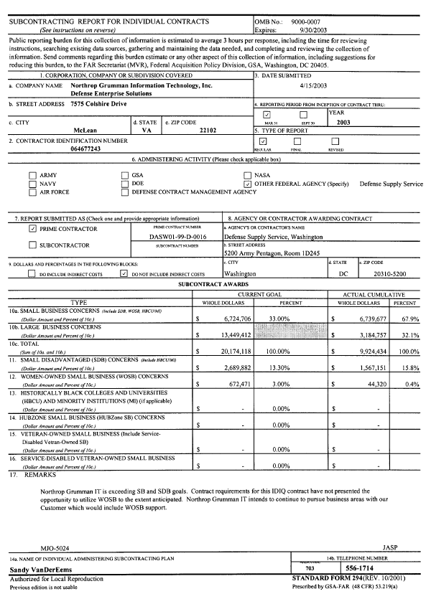

1. Complete Name of Reference (Government agency, commercial firm, or other organization)
Information Assurance Technology Analysis Center (IATAC) Delivery Order 75, Capt Young Kim, USN, OPNAV N61FP
2. Complete Address of Reference
Pentagon Navy 2000 Washington, DC 20350-2000
3. Contract Number or other control number  SPO700-98-D-4002 Delivery Order 075 | 4. Date of contract  Contract: 15 May 98; Delivery Order 75: 24 July 00
5. Date work was begun  24 July 2000 | 6. Date work was completed  Ongoing – Option Period ends 5/04
7. Contract type, initial contract price, estimated cost and fee, or target cost and profit or fee  CPFF, $24M | 8. Final amount invoiced or amount invoiced to date. Reference cost overruns and what percentage of the total contract was overrun if applicable  Invoiced as of 30 April 03: $13.8M
9a. Reference/Technical point of contact (name, title, address, telephone no. and email address)  Captain Young Kim  The Office of the Chief of Naval Operations (N61FP)  Pentagon Navy 2000  Washington, D.C. 20350-2000  703-601-1450 young.kim1@navy.mil | 9b. Reference/Contracting point of contact (name, title, address, telephone no. and email address)  Ms Nancy Pfeil, DTIC-IA  Defense Technical Information Center  8725 John J Kingman Road Ste 0944  Ft. Belvoir, VA 22060-6218  703-767-9117 npfeil@dtic.mil
10. Location of work (country, state or province, county, city)
Arlington, VA

11. Current status of contract (choose one):
[X] Work continuing, on schedule [ ] Terminated for Convenience
[ ] Work continuing, behind schedule [ ] Terminated for Default
[ ] Work completed, no further action pending or underway [ ] Other (explain)
[ ] Work completed, routine administrative action pending or underway
[ ] Work completed, claims negotiations pending or underway
[ ] Work completed, litigation pending or underway
12. Provide brief information describing the success of your firm in furthering the policy of the United States to maximize practicable opportunities for small business concerns, HUBZone small business concerns, small disadvantaged business concerns, women owned small business concerns, veteran-owned small business concerns and service-disabled veteran-owned small business concerns.
Booz Allen Hamilton is committed to providing subcontracting opportunities to small, small disadvantaged, women-owned, HUBZone, veteran-owned, and service disabled veteran-owned small business concerns and this message is echoed from the top down. Our President, Dr. Ralph Shrader has issued our company-wide policy, which is to provide subcontracting opportunities to Small, Minority-owned, and Women-owned Businesses. We also encourage program managers to consider use of Historically Black Colleges and Universities (HBCU), Minority Institutions (MI), and businesses located in Historically Underutilized Business Zones (HUBZones) as potential subcontractors. As a supporter of these types of team partners, we help our program managers to consider the use of businesses located in labor surplus areas as potential subcontractors. Our policy is to seek out such businesses and organizations when it is necessary to supplement our in-house professional, technical, and support capabilities and to enter into mutually beneficial business agreements with them.
13. When contracting with firms described in part 12 above, describe what, if any, procedures your firm established to ensure timely payment of amounts due.
In accordance with FAR 19.702, under Statutory Requirements, Booz Allen has established and uses procedures to ensure the timely payment of amounts due pursuant to the terms of our subcontracts with small, small disadvantaged, women-owned small business, HubZone small business, veteran-owned and service disabled veteran-owned small business concerns. Booz Allen will pay the Subcontractor no later than thirty (30) days after the receipt by the Booz Allen Finance Department (Subcontracts Invoice Processing Group) of a proper invoice, submitted in accordance with the Instructions provided in our negotiated Subcontract agreements. All invoices must be signed and approved by an authorized official of the Subcontractor, who shall certify that the invoiced amounts are accurate and that the Subcontractor has in its possession records for all amounts for which payment is requested.
14a. Did this contract require a Small Business Subcontracting Plan pursuant to FAR 52.219-9? Yes _XX , No _
14b. If “Yes” to 14a, have you regularly submitted SF 294/295 reports on time? Yes _XX_ , No ___.
14c. Attach a copy of your most recently submitted SF 294. (Delivered to SPAWAR separately)
14d. Attach a copy of your most recent DCMA Subcontracting Program Compliance Review rating (Delivered to SPAWAR separately)
15. Provide a summary description of contract work, not to exceed two pages in length. Describe the program title, nature and scope of work, its relevancy to this contract, a description of any problems encountered, your corrective actions, names of personnel proposed in this technical proposal who also have worked on the above identified contracts and the extend of participation of small disadvantaged business concerns in performance of the contract. Attach the explanation to this form.

Title: Information Assurance Technology Analysis Center (IATAC) Delivery Order 75

Scope of Work: IATAC Delivery Order (DO) 75 provides the Department of the Navy technical, system, and process analysis in Information Operations focusing on Command, Control, Communications, Computers, Intelligence, Surveillance, and Reconnaissance (C4ISR) continuum. A broad range of activity including general planning, programmatic support, tabletop exercises, modeling and simulation, workshops and conferences, special studies, requirement analysis, and assessments is conducted.

Nature of Work: Issue analysis using M&S and DoD Architecture Framework tools where applicable; effects-based modeling, simulation, and analysis; assisted with requirement definition in several MCPs.

Relevance of Work: We have been providing a broad range of analyses and subject matter expertise to OPNAV N61 (previously N6) (Strategic Planning and FORCEnet), N70 (Strike MCP and Sea Strike), N81 (ISS IWAR), and ASN RDA CHENG (architecture analysis for the Fleet Battle Experiment process and OPNAV MCPs). Selected tasks on this DO are discussed.

ISS IWAR, OPNAV N81 - We have provided analytical support to the ISS IWAR since inception of the IWAR process in 1998. Prior to that, we provided analytical support to the ISR and C4 Joint Mission Area; again from inception of the JMA process in the fall of 1992. We recently completed the following three tasks for the ISS IWAR:
- For POM-04 the ISS IWAR, we collected ISS issues from the Fleet for an ISS health assessment. We grouped the 700 responses and assisted the IWAR team in analyzing these issues to enable developing programmatic recommendations.
- Also for POM-04, we used our Integrated Gaming System effects based modeling to measure the effects of disorder on both forces in a Red invasion of Green using real world operational examples as the data baseline. We captured the effects of Red’s information operations on Green’s warning, air defenses, and C2. We captured the effects of Green’s information operations on Red’s C4ISR effectiveness and warfighting capability.
- In the summer of 2002 we identified the bandwidth requirements of Naval forces in the PR-05 Western Pacific scenario in FY 09 and compared their requirements against the satellite communication services projected for FY 09. We coordinated with OPNAV N61, and Naval Space Command to ensure we properly represented the demand for and availability of SATCOM services. Demand was built on scenario requirements from the Power Projection, Air Dominance, and Maritime Dominance IWARS, and related ISS IWAR analyses. Wideband, narrowband, and protected communications were assessed.
BFC2 and FORCEnet, OPNAV N61 - Booz Allen’s analytical support to OPNAV N61FP (formerly N6C) predates the Joint Mission Area (JMA) assessment process in 1992, and has continued uninterrupted since 1992. Recent analyses have focused on BFC2 and FORCEnet. In 2001, we assisted then OPNAV N6C in defining BFC2 requirements for Time Critical Targeting. BFC2 requirements were presented in the DOD C4ISR Architecture Framework using a family of operational and system architecture views. We used Navy mission essential task lists (NMETLS) as a basis for required capabilities and we conducted a capability gap analysis based on systems in SSC Charleston’s Naval Tool for Interoperability and Risk Assessment (NTIRA) database.

Current support to N61 includes participation in the N61 FORCEnet analysis group that is identifying FORCEnet requirements. We are building a relational database of key thoughts that bear on FORCEnet from over one hundred documents, reports and analyses and we are mapping them to the 27 FORCEnet capability objectives. We continue to provide real time response to quick turn-around requests for thought leadership in articulating and presenting FORCEnet issues and capabilities for Flag reviews of the FORCEnet pillar inputs to the ISCP.

STRIKE MCP / SEA STRIKE - Support to OPNAV N70 began with the Time Critical Strike (TCS) MCP for POM-04, and continued into the Strike MCP and the Sea Strike pillar of Sea Power 21 for PR-05. We posed a series of questions for the TCS MCP and then used those questions to frame our analysis for POM-04: The questions addressed requirements, contributing systems, capability gaps and overlaps, the impact of schedule and capability changes on the overall TCS capability and performance differences between alternate solutions to TCS shortfalls. From these questions, we defined the TCS capability, and recommendations that the TCS MCP Team Leader briefed to the CNO for POM-04. We collaborated with the ASN RDA CHENG team and used their architecture products as an analysis basis for the recommendations. Through POM-04 and PR-05 we worked with the BFC2, NAV, and ISR MCPs to understand how their areas affected Strike and to identify Strike requirements to these supporting MCPs. Further, in response to the VCNO’s comments, we did a quick reaction analysis of fleet defenses against swarming small boats. In that analysis, we expanded the modeling tool to accommodate a broader scope of systems and data than used in a preliminary analysis. Since a spreadsheet approach was sufficient to address the analysis issues model changes were possible in the short time available.

ASN RDA CHENG - Booz Allen has assisted ASN RDA CHENG in architecture development for over two years and supported CHENG in developing the operational architecture for Fleet Battle Experiment (FBE) India. The goal of FBE India was to develop and assess Time Critical Strike architectures supporting OPNAV acquisition decisions while developing an overall CHENG architecture process. The FBE India TCS architecture effort focused on providing discipline in analyzing TCS operational, systems and technical architecture views; evaluating the architecture analysis process, and identifying key system capability integration solutions for TCS. We applied our Joint Mission Area Analysis Tool (JMAAT) to integrate and visualize the architecture views. JMAAT products assisted in ensuring full integration and interoperability of warfighter systems, resulting in enhanced information exchange within the battle space. Booz Allen integrated the FBE-India architecture with operational architectures that were being developed for the Naval Afloat Targeting Integrated Product Team and the ONR led Tasking, Processing, Evaluation and Dissemination architecture for the POM 04 TCT MCP. Insights from FBE-India, and data from the TPED and NAT IPT efforts supported development of 37 program recommendations submitted to OPNAV N70 in November of 2001.

Problems Encountered/ Corrective Actions: No problems encountered.

Proposed Personnel: The following personnel engaged in the above work will support the new contract: John Draper, Kevin Murray, Marc Anderson, Gary Faller, and Steve Sass.

Small Business Participation: N/A

[M-5.5]

1. Complete Name of Reference (Government agency, commercial firm, or other organization)
Marine Corps Studies Program, Marine Corps Combat Development Command, Studies Management Branch

2. Complete Address of Reference
3300 Russell Road, Quantico, VA 22134-5130
3. Contract Number or other control number  M00264-01-D-0001 | 4. Date of contract  20 November 2000
5. Date work was begun  20 November 2000 | 6. Date work was completed  Work Continuing
7. Contract type, initial contract price, estimated cost and fee, or target cost and profit or fee  IDIQ, $5.9M ceiling over five year period | 8. Final amount invoiced or amount invoiced to date. Reference cost overruns and what percentage of the total contract was overrun if applicable  Invoiced to date - $4,414,474.69 - - No overruns
9a. Reference/Technical point of contact (name, title, address, telephone no. and email address)  Mr. Michael L. Durnavich, Hd. Studies Mgmt.  MCCDC Studies & Analysis  3300 Russell Road, Quantico, VA 22134-5130  703-784-6021  durnavichml@mccdc.usmc.mil | 9b. Reference/Contracting point of contact (name, title, address, telephone no. and email address)  Ms. Wanda Wichmann, Contracting Officer  Northeast Regional Contracting Office (B401)  3250 Catlin Avenue, Quantico, VA 22134-5001  703-784-1930  wichmannws@nt.quantico.usmc.mil
10. Location of work (country, state or province, county, city)
Quantico, VA
11. Current status of contract (choose one):
[XXX ] Work continuing, on schedule [ ] Terminated for Convenience
[ ] Work continuing, behind schedule [ ] Terminated for Default
[ ] Work completed, no further action pending or underway [ ] Other (explain)
[ ] Work completed, routine administrative action pending or underway
[ ] Work completed, claims negotiations pending or underway
[ ] Work completed, litigation pending or underway
12. Provide brief information describing the success of your firm in furthering the policy of the United States to maximize practicable opportunities for small business concerns, HUBZone small business concerns, small disadvantaged business concerns, women owned small business concerns, veteran-owned small business concerns and service-disabled veteran-owned small business concerns.

Three small businesses were bid as part of the Northrop Grumman (formerly TRW Systems) Team. These small businesses actively participate in our studies and analysis work, contributing significantly (up to 50 % of the staffing) in seven of the fifteen task order studies to date.
13. When contracting with firms described in part 12 above, describe what, if any, procedures your firm established to ensure timely payment of amounts due.

Subcontractor invoices from the small businesses supporting this contract receive priority handling by our Subcontracts Administrator and the Program Manager. As a matter of routine, invoices are approved for payment within 8 hours of receipt. Payment terms for small businesses are -Net 30.
14a. Did this contract require a Small Business Subcontracting Plan pursuant to FAR 52.219-9? Yes ___ , No _X__.
14b. If “Yes” to 14a, have you regularly submitted SF 294/295 reports on time? Yes ___ , No ___.
14c. Attach a copy of your most recently submitted SF 294.
14d. Attach a copy of your most recent DCMA Subcontracting Program Compliance Review rating
15. Provide a summary description of contract work, not to exceed two pages in length. Describe the program title, nature and scope of work, its relevancy to this contract, a description of any problems encountered, your corrective actions, names of personnel proposed in this technical proposal who also have worked on the above identified contracts and the extend of participation of small disadvantaged business concerns in performance of the contract. Attach the explanation to this form.

Title: Marine Corps Studies Program

Scope of work: Under this project, Northrop Grumman IT performs studies and analyses in support of the Marine Corps Studies Program. Studies and Analysis requirements are identified through task orders. An individual statement of work that includes specific tasking guides the performance of each study effort. Northrop Grumman IT fields multiple study teams to perform analytical tasking in the following subject areas: (1) Combat Modeling, Simulation and Wargaming, (2) concurrently fielding multiple study teams Command, Control, Communications, and Computers (C4), (3) Concept Development, (4) Cost Estimation and Cost/Benefit Analysis, (5) Decision Analysis, (6) Feasibility Analysis, (7) Geo-Political, Economic, and Demographic Forecasting, (8) Intelligence, (9) Analysis of Alternatives, (10) Scenario Development, (11) Technological Forecasting, and (12) Weapons Systems Analysis.

Nature of work: To date, Northrop Grumman IT task order analyses were performed and continue under this contract as noted:
- Developed an Operational Mode Summary/Mission Profile for Marine Corps employment of the High Mobility Artillery Rocket System (HIMARS). This effort involved extensive analysis of this fire support system and involved OPSIT development and combat modeling of various employment schemes and types of ammunition.
- Supported Project Albert, a Marine Corps research effort, by developing a platform to model individual and group behaviors and then prepared this application for data farming in high performance computing environments. The Pythagoras simulation developed under effort has been favorably received in the Military Operations Research community and has been adopted for use at the Naval Postgraduate School and two of the Service academies.
- Performed an Analysis of Alternatives for the Marine Corps Multi-Role Radar System. This effort involved extensive engineering-level radar modeling, technical feasibility analysis, and combat effectiveness analysis at the campaign level.
- Continue to support the Marine Corps involvement in the development to Joint Warfare System (JWARS) simulation. Sub-tasks involve comprehensive JWARS testing to examine the simulation’s suitability to replicate Marine Corps expeditionary warfighting concepts.
- Continue to provide on-site support to the Marine Corps Lessons Learned effort for both Operations ENDURING FREEDOM and IRAQI FREEDOM. For this effort a comprehensive knowledge management system, including a classified Oracle database, was developed to gather, analyze, index, and store myriad classified documents and data relevant to Marine Corps involvement in these two campaigns.
- Analyzed the combat effectiveness of the future Marine Corps fire support systems to develop a further understanding of the particular requirements needed in a future Expeditionary Fire Support System (EFSS).
- In a follow-on effort, we are performing the formal EFSS Analysis of Alternatives.
- Developed a comprehensive process model of the imagery analysis support process for attacking time critical targets in the Marine Corps. Performed for the HQMC Intelligence Directorate, this effort provides a tool built in the Extend simulation environment suitable for future analyses of a variety of imagery analysis issues.
- Performed a Marine Air Ground Task Force optical capabilities study to develop a greater understanding of the best mix of optical devices for the future warfighting force.
- Performed supplemental cost analysis for the AAAV program focused on the cost implications of varying reliability and maintenance key performance parameters of this key Marine Corps system.
- Developing a migration strategy for the Marine Corps’ fielding of the Joint Tactical Radio System.
- Conducting a scenario-driven, quantitative analysis of the Baseline 2015 MEB in order to determine Combat Service Support (CSS) and C2 organizations, structure and capabilities required to support combat operations employing Marine Corps operating concepts as expressed in Expeditionary Maneuver Warfare. These analyses will assess the projected Baseline 2015 MEB capabilities, identify deficiencies, develop and analyze alternatives, and recommend solutions for Baseline 2015 MEB CSS and C2 warfighting requirements, with a particular focus on sea-basing.
- Developing four future Marine Corps warfighting scenarios from those issued by the Office of the Secretary of Defense to provide an appropriate context for studies, war games, analyses, experimentation, training exercises, and Mission Area Analyses.

Relevancy to this contract: The Marine Corps Studies Support project is completely relevant to this contract in that it is the Marine Corps counterpart to N81’s assessment effort. Northrop Grumman IT’s efforts in Marine Corps Studies to date have touched on virtually all focus area of this N81 contract - - Warfare and Support Assessments; the CNO’s Investment Strategy (in understanding Navy support to the Marine Corps); Analysis Support Functions; Technology Assessments,; and Special Studies/Analyses.

Problems Encountered/ Corrective Actions: None.

Proposed Personnel: The following personnel engaged in the above work will support the new contract: John Chalecky and Donna Middleton.

Small Business Participation: In seven of the above noted task order studies conducted to date, small businesses have contributed up to 50% and more of the efforts involved.

1. Complete Name of Reference (Government agency, commercial firm, or other organization)

Engineering Technical, Research, and Support Services to Space and Naval Warfare (SPAWAR) Systems Center, Charleston (SPAWARSYSCEN Charleston)
2. Complete Address of Reference
Space and Naval Warfare Systems Center
Post Office Box 190022, Code 1115SD
North Charleston, SC 29419-9022
3. Contract Number or other control number  N65236-99-D-5711  N65236-01-D-5714 follow-on to N65236-99-D-5711 | 4. Date of contract  N65236-99-D-5711 - 30 September 1999 -  31 May 2001
5. Date work was begun  N65236-99-D-5711 - 30 September 1999  N65236-01-D-5714 - 14 September 2001 | 6. Date work was completed  N65236-99-D-5711 - 31 October 2002  N65236-01-D-5714 - On-Going
7. Contract type, initial contract price, estimated cost and fee, or target cost and profit or fee  N65236-99-D-5711 N65236-01-D-5714  Contract Type Time & Material Time & Material  Target Price $2,852,958.65 $2,949,781.40  Target Fee N/A N/A | 8. Final amount invoiced or amount invoiced to date. Reference cost overruns and what percentage of the total contract was overrun if applicable  Invoice amounts through April 2003 for these contracts are: N65236-99-D-5711 $2,679,450  N65236-01-D-5714 $1,556,701  To date there have been no overruns on either contract
9a. Reference/Technical point of contact (name, title, address, telephone no. and email address)  Mr. Greg Bryant  Space and Naval Warfare Systems Center  Post Office Box 190022, Code 51GB  North Charleston, SC 29419-9022  (843) 218-4814  bryantg@spawar.navy.mil | 9b. Reference/Contracting point of contact (name, title, address, telephone no. and email address)  Ms. Debbie Spencer, Contracts Specialist  Space and Naval Warfare Systems Center  Post Office Box 190022, Code 1115SD  North Charleston, SC 29419-9022  (843) 218-5822  spencerd@spawar.navy.mil
10. Location of work (country, state or province, county, city)

USA: Washington, DC, Riverdale MD, Norfolk, VA, San Diego, CA
Various European and Pacific Rim locations depending on Navy requirements

11. Current status of contract (choose one):
[5714] Work continuing, on schedule [ ] Terminated for Convenience
[ ] Work continuing, behind schedule [ ] Terminated for Default
[ ] Work completed, no further action pending or underway [ ] Other (explain)
[5711] Work completed, routine administrative action pending or underway
[ ] Work completed, claims negotiations pending or underway
[ ] Work completed, litigation pending or underway
12. Provide brief information describing the success of your firm in furthering the policy of the United States to maximize practicable opportunities for small business concerns, HUBZone small business concerns, small disadvantaged business concerns, women owned small business concerns, veteran-owned small business concerns and service-disabled veteran-owned small business concerns.

Gryphon Technologies is a woman owned small business.
13. When contracting with firms described in part 12 above, describe what, if any, procedures your firm established to ensure timely payment of amounts due.

Not Applicable
14a. Did this contract require a Small Business Subcontracting Plan pursuant to FAR 52.219-9? Yes ___ , No X .
14b. If “Yes” to 14a, have you regularly submitted SF 294/295 reports on time? Yes ___ , No ___.
14c. Attach a copy of your most recently submitted SF 294.
14d. Attach a copy of your most recent DCMA Subcontracting Program Compliance Review rating
15. Provide a summary description of contract work, not to exceed two pages in length. Describe the program title, nature and scope of work, its relevancy to this contract, a description of any problems encountered, your corrective actions, names of personnel proposed in this technical proposal who also have worked on the above identified contracts and the extend of participation of small disadvantaged business concerns in performance of the contract. Attach the explanation to this form.

Title: Engineering Technical, Research, and Support Services to Space and Naval Warfare (SPAWAR) Systems Center, Charleston (SPAWARSYSCEN Charleston).

Scope of Work: Provide SPAWARSYSCEN Charleston, Tactical Switching Branch (Code 511), technical expertise, knowledge and support on shipboard Integrated Voice communications and data systems that include: Advanced Digital Network System (ADNS); Integrated Voice Network (IVN); Integrated Voice Communications System (IVCS); and Hierarchical Yet Dynamically Reconfigurable Architecture (HYDRA) wirefree communications.

Nature of Work: The principal disciplines provided under this contract include: program management, systems acquisition, systems engineering and integration, evolving technology insertion and standards compliance, configuration control, in-service engineering, and life-cycle management.

Relevance of Work: As part of contract N65236-99-D-5711/Delivery Orders 0006, 0007, 0009, and 0010 Gryphon has supported SPAWARSYSCEN Charleston in the design, installation, integration, administration, testing, and development of training materials for Interior Communications (IC) systems including: IVS, IVN, SATCC, MCS2000, and HYDRA. This support has been provided on numbers of ship classes including: LCC, LHA, LHD, and AGF. Highlights of this general support are provided as follows:
- Participate in IC related reviews, technical meetings, conferences, and ad hoc meetings at vendor facilities, shipbuilder facilities, and Navy installations.
- Provide programmatic/technical input in the preparation of IC systems design and installation planning documentation, including Terminal Configuration Lists and Ship Alteration Installation Drawings (SIDs).
- Perform data gathering, engineering evaluations, and develop recommended technical solutions in response to action items and problems as they arise related to IC system design, integration, installation, and testing.
- Perform shipchecks to develop system design baselines and to validate material requirements and SIDs.
- Develop system training, technical manuals, system manuals, and general information notebooks as required.

Specifically for the LHD 7, Gryphon provided the following support.
- Provided on-site representation and support for the installation, integration, and administration, and testing of the IC systems on board the LHD 7 during the ship’s construction and post delivery availability period.
- Performed Pre-Builder’s Trial and Builder’s Trial (BT) shipchecks and provided technical support/representation during the conduct of LHD 7 BTs. This support was provided at both the dock and at-sea trials.
- Provided support/representation during the conduct of the LHD 7 Acceptance Trials (AT). This support included briefings and technical assistance to the Board of Inspection and Survey Inspectors concerning LHD 7 IC systems.
- Performed technical support services during the LHD 7 CSSQT.
- Evaluated all changes to the LHD 7 combat systems/subsystem and engineering system/subsystem hardware and software for impacts to the IC systems (voice, alarm, and indicating).
- Provided technical support/representation at combat system/subsystem design/progress reviews, Quarterly Program Reviews/Technical sessions, Combat Systems Working Groups, and other meetings as required.
Because of our past performance in supporting the LHD 7, Gryphon is now under contract to support the LHD 8. In support of the baseline (Tier 1) configuration, Gryphon will review and evaluate the LHD 8 combat system/subsystem and engineering system/subsystem baseline contract and detailed design for discrepancies or inconsistencies that may impact the LHD 8 shipboard IC systems. Deficiencies and concerns will be documented and a technical impact report will be prepared that will also recommend resolutions to the issues/problems.

Under contract N65236-01-D-5714/Delivery Orders 0001 & 0006, Gryphon is providing support to Space and Naval Warfare Systems Center, Charleston’s SCN C4I Program Manager for LHD Platforms and the NSWC PHD Project Manager for the LHD 7 Combat System Ship’s Qualification Test (CSSQT). In support of NSWC PHD Project Manager for the LHD 7 CSSQT we performed the following tasks.
- During in-port testing we were tasked to verify the configuration, operation, and material condition of the ship’s radio communications system.
- Additionally we provided technical support and training on C4I systems throughout the at-sea phase of the CSSQT.
- We participated in CSSQT related reviews, technical meetings, conferences, and ad hoc meetings at vendor facilities, shipbuilder facilities, and Navy installations.
- As required, we provided small hardware items such as connectors, cables, and other small items necessary to correct minor equipment problems.
- We provided support in the correction of system discrepancies.
- We assisted the ship’s crew in the performance of preventative and corrective maintenance.
For the C4I Program Manager for LHD Platforms we provide the following.
- We provide support related to C4I and communications systems equipment installations, upgrades, and repairs wile the LHD 7 is in its scheduled Restrictive Availability and post Shakedown Availability periods.
- We are tasked to provide technical support and familiarization on C4I systems throughout the INSURV final Contract Trial. As required we will provide the ship’s crew familiarization with any of the various C4I systems onboard the LHD 7.
- We participated in reviews, technical meetings, conferences, and ad hoc meetings at vendor facilities, shipbuilder facilities, and Navy installations.

Problems Encountered/ Corrective Actions: None.

Proposed Personnel: The following personnel have provided part time support on the contract and are proposed for this effort: Kevin Ashley, Fred Everett, and David Velasquez.

Small Business Participation: N/A – Gryphon is an 8a certified Small Woman Owned Business.
1. Complete Name of Reference (Government agency, commercial firm, or other organization)
Mission Area Analysis, Studies and Analysis Division, Marine Corps Combat Development Command
2. Complete Address of Reference
3300 Russell Road (Code 454), Quantico, VA 22134
3. Contract Number or other control number  GS35F4506G M00264-99-F-2408 | 4. Date of contract  20 September 1999
5. Date work was begun  20 September 1999 | 6. Date work was completed  15 November 2002
7. Contract type, initial contract price, estimated cost and fee, or target cost and profit or fee  T&M; $4,319,465 | 8. Final amount invoiced or amount invoiced to date. Reference cost overruns and what percentage of the total contract was overrun if applicable  $ 4,323,612
9a. Reference/Technical point of contact (name, title, address, telephone no. and email address)  Mr. William A. Sawyers  Head, MAA Branch, Studies and Analysis Division  Marine Corps Combat Development Command  3300 Russell Road, Quantico, VA 22134  sawyerswa@mccdc.usmc.mil; 703 784-6025 | 9b. Reference/Contracting point of contact (name, title, address, telephone no. and email address)  Mr. Michael Durnavich  Head, Studies Management Branch, Studies and Analysis Division  Marine Corps Combat Development Command  3300 Russell Road, Quantico, VA 22134  durnavichm@mccdc.usmc.mil; 703-784-4766
10. Location of work (country, state or province, county, city)
Marine Corps Base, Quantico, Prince William County, VA 22134
11. Current status of contract (choose one):
[ ] Work continuing, on schedule [ ] Terminated for Convenience
[ ] Work continuing, behind schedule [ ] Terminated for Default
[ ] Work completed, no further action pending or underway [ ] Other (explain)
[X ] Work completed, routine administrative action pending or underway
[ ] Work completed, claims negotiations pending or underway
[ ] Work completed, litigation pending or underway
12. Provide brief information describing the success of your firm in furthering the policy of the United States to maximize practicable opportunities for small business concerns, HUBZone small business concerns, small disadvantaged business concerns, women owned small business concerns, veteran-owned small business concerns and service-disabled veteran-owned small business concerns.
N/A
13. When contracting with firms described in part 12 above, describe what, if any, procedures your firm established to ensure timely payment of amounts due.
N/A
14a. Did this contract require a Small Business Subcontracting Plan pursuant to FAR 52.219-9? Yes ___ , No X.
14b. If “Yes” to 14a, have you regularly submitted SF 294/295 reports on time? Yes ___ , No ___.
14c. Attach a copy of your most recently submitted SF 294.
14d. Attach a copy of your most recent DCMA Subcontracting Program Compliance Review rating
15. Provide a summary description of contract work, not to exceed two pages in length. Describe the program title, nature and scope of work, its relevancy to this contract, a description of any problems encountered, your corrective actions, names of personnel proposed in this technical proposal who also have worked on the above identified contracts and the extend of participation of small disadvantaged business concerns in performance of the contract. Attach the explanation to this form.

Title: Mission Area Analysis (MAA) Studies and Analysis Support

Scope of Work: Northrop Grumman Information Technology conducted Mission Area Analyses for the Marine Corps. For each specific MAA, Northrop Grumman Information Technology conducted a thorough study of Marine Corps operations and capabilities to identify deficiencies in the context of an approved scenario. Each study combined the most appropriate quantitative and qualitative analytical techniques to arrive at the findings. Northrop Grumman Information Technology provided dedicated on-site modeling, combat simulation, historical research, and analysis support to the Studies and Analysis Division, Marine Corps Combat Development Command. The initial MAA contract was awarded in 1997. The contract cited in this attachment was the follow-on to the initial contract and was awarded in September 1999.

Nature of Work: The Mission Area Analysis (MAA) Team analyzed Marine Corps force structure and modernization using existing models and state of the art analytical application tools. The MAAs assessed and reported on the capability of Marine Air Ground Task Forces (MAGTF) and weapons systems using models such as the Vector-in-Commander (VIC) combat simulation, GCAM, and EXTEND that record the performance of forces in out-year scenarios. It evaluated the effectiveness of weapons systems and force structures in a realistic environment. The MAA Team analyzed force capability implications of future Marine Corps programs as applied to units 10 years in the future. The team provided analytical support on the combat effectiveness of weapons systems by operating and evaluating the results of combat, engineering, or other models. To conduct each MAA, the team updated databases and models as needed to enable analysis of projected forces and equipment. They then performed statistical and mathematical analysis on the outcomes to quantify relationships among various data elements. To complete each MAA, the MAA Team furnished graphical displays, tables of data, and written reports for use in the Marine Corps requirements determination process. This included preparing briefings and/or computer graphic presentations that reflected the analytical findings, conclusions, and recommendations. Northrop Grumman Information Technology completed the first MAA, which analyzed a Noncombatant Evacuation Operation, in February 1998 and was cited by Marine Corps leadership for the outstanding quantitative and qualitative analytic approach used. Northrop Grumman Information Technology completed fifteen MAA studies over the course of the two contracts. The MAAs are scenario-based and cover a spanning set of Marine Corps operations. Completed MAAs have investigated both Marine Corps Expeditionary Forces and Marine Corps Expeditionary Brigades (MEB) conducting forcible entry operations in both Northeast Asia and Southwest Asia. The MAA team has studied the MEB and MEF conducting sustained operations ashore in the same areas of the world. Three Military Operations Other than War (MOOTW) were analyzed: peacekeeping operations, noncombatant evacuation operations, and humanitarian assistance/disaster relief. Overall, the MAA team has completed 12 scenario-based MAAs and is working on the 13th. The final MAA investigated issues involving military operations on urban terrain and identified several areas where the Marine Corps needs to place emphasis to ensure Marine units can operate successfully in that harsh environment. Five other related studies have been completed, including a modeling and simulation overview and an evaluation of the GCAM modeling environment.

Relevance to this contract: The MAA contract had specific relevance to this contract in the areas specified below.

(1) Scenario Development.
(2) Development of Capability Characterization Measures.
(3) Data Base Maintenance and Development.
(4) Model and Simulation Maintenance and Development.

The current Marine Corps Mission Area Analysis process is scenario-based. Northrop Grumman Information Technology developed and executed the current process for the Marine Corps Combat Development Command (MCCDC). As a key part of each MAA, the MAA team coordinated with the appropriate intelligence analysts to ensure the study used an accurate up-to-date threat force. It conducted the same kind of coordination with Marine Corps subject matter experts to obtain the same data for the friendly forces. The team hosted a Mission Analysis, led by a MCCDC colonel, to obtain an operational concept that accurately portrayed the latest Marine Corps thinking for future operations. In some cases, there were no prepared scenarios and the MAA team developed the information necessary for the conduct of the study. The MAAs on Peacekeeping and on Humanitarian Assistance are two examples.

The purpose of the MAA was to identify deficiencies in the capabilities of Marine forces to perform their assigned missions. The MAA team developed and used a capabilities list based on the Naval Tactical Task List as the basis for its analysis of force effectiveness in a given scenario. The primary combat simulation used for mission area analysis was the Vector-in-Commander (VIC), which is a widely used and accepted U.S. Army operational level model. VIC has a large data base, which required constant updating and maintenance. VIC was updated several times during the MAA contract. Each upgrade caused the team to “scrub” the data and ensure the Marine Corps equipment and units remained accurately represented. Because each scenario was unique, new units and concepts of operations had to be added to the database and debugged. The MAA team had extensive experience in these tasks and was very proficient in modifying VIC databases.

The MAA team developed specific models of amphibious landings using GCAM. Each MAA that had an amphibious landing required its unique landing model. The team developed several innovative techniques to simulate and analyze the details of an amphibious assault. The GCAM visualization was well received by the customer and helped to explain why some landings exceeded the desired time to put troops ashore.

Each MAA was documented with a detailed report that provided the background, scenario details, and the identified deficiencies against the capabilities list that had been validated for that MAA. A results briefing was also provided, with a briefing normally presented to the Director for Expeditionary Warfare Development.

Problems Encountered/ Corrective Actions: N/A

Proposed Personnel: The following personnel worked on the contract and are proposed for this effort, Allan Escobar and Allie Felder.

Small Business Participation: N/A

1. Complete Name of Reference (Government agency, commercial firm, or other organization)

OSD PA&E Conventional Forces Planning and Comparison Databases, Analytical and Decision Support Systems and Modeling and Simulation Support - U.S. Conventional Forces, OSD PA&E
2. Complete Address of Reference
OSD OD PA&E (TA&P) Projection Forces Division
3. Contract Number or other control number  DASW01-02-A-0011 (AT&T)/DASW01-02-A-0012 (NGIT) | 4. Date of contract  April 22, 2002
5. Date work was begun  August 1997 | 6. Date work was completed  August 2002
7. Contract type, initial contract price, estimated cost and fee, or target cost and profit or fee  BPA - GSA | 8. Final amount invoiced or amount invoiced to date. Reference cost overruns and what percentage of the total contract was overrun if applicable  $4.5M
9a. Reference/Technical point of contact (name, title, address, telephone no. and email address)  Camellia Rush  Defense Supply Service, Washington  5200 Army, Pentagon  Washington, DC 20310-5200  Telephone: 703-693-2139  E-Mail: Carmelia.Rush@HQDA.Army.mil | 9b. Reference/Contracting point of contact (name, title, address, telephone no. and email address)  Leroy Hicks  OSD PA&E  1800 Defense – Room 2D279  Pentagon, Washington DC 20301  Telephone: 703-695-7935  E-Mail: Lee.Hicks@OSD.Pentagon.mil
10. Location of work (country, state or province, county, city)

Roslyn, Virginia

11. Current status of contract (choose one):
[X] Work continuing, on schedule [ ] Terminated for Convenience
[ ] Work continuing, behind schedule [ ] Terminated for Default
[ ] Work completed, no further action pending or underway [ ] Other (explain)
[ ] Work completed, routine administrative action pending or underway
[ ] Work completed, claims negotiations pending or underway
[ ] Work completed, litigation pending or underway
12. Provide brief information describing the success of your firm in furthering the policy of the United States to maximize practicable opportunities for small business concerns, HUBZone small business concerns, small disadvantaged business concerns, women owned small business concerns, veteran-owned small business concerns and service-disabled veteran-owned small business concerns.
N/A
13. When contracting with firms described in part 12 above, describe what, if any, procedures your firm established to ensure timely payment of amounts due.

14a. Did this contract require a Small Business Subcontracting Plan pursuant to FAR 52.219-9? Yes ___ , No _X__.
14b. If “Yes” to 14a, have you regularly submitted SF 294/295 reports on time? Yes ___ , No ___.
14c. Attach a copy of your most recently submitted SF 294.
14d. Attach a copy of your most recent DCMA Subcontracting Program Compliance Review rating
15. Provide a summary description of contract work, not to exceed two pages in length. Describe the program title, nature and scope of work, its relevancy to this contract, a description of any problems encountered, your corrective actions, names of personnel proposed in this technical proposal who also have worked on the above identified contracts and the extend of participation of small disadvantaged business concerns in performance of the contract. Attach the explanation to this form.

Title: OSD PA&E Conventional Forces Planning and Comparison Databases, Analytical and Decision Support Systems and Modeling and Simulation Support - U.S. Conventional Forces

Scope of Work: AT&T and Northrop Grumman IT conduct joint collaborative and independent analyses and provide analytical and technical support for the Office of the Secretary of Defense’s Program Analysis and Evaluation (OSD PA&E) Directorate, in the Simulation and Analyses Center (SAC). Within the DPA&E SAC, the two contractors work collaboratively to conduct assessments of Planning Programming and Budgeting System (PPBS) issues, analyses of alternatives, mission area analyses, value-added analyses, and future defense reviews. Contractor tasks include: structuring of objectives and analytic approaches for planned studies; recommending hardware, software, and staffing resources needed to conduct studies; developing model-specific scenarios of appropriate regions and operational theaters; obtaining and adapting data from multiple sources into model inputs; analyzing the input data and model results to address the study objectives; interpreting and accounting for model specifics and ambiguities; and preparing reports of analysis of model results.
Nature of Work: Create study plans and OPSITs, design model scenario files, populate model data, run the models, analyze the results, and prepare briefings/reports. Design, develop, implement, and integrate model enhancements; perform software integration functions on large, software intensive modeling and simulation projects; support continuing study and analysis efforts; perform requirements analysis, high-level design, and detailed design, implementation, and integration.

Relevance to this contract: The team operates a number of computer combat models and has participated in many of the key DoD studies.
- TACWAR (TACtical WARfare model) is used by the SAC to examine theater land, air, logistics, SSM, and chemical issues. TACWAR is currently the standard warfare model for joint collaborative analysis between OSD PA&E and the Joint Staff (J-8).
- JICM (Joint Integrated Contingency Model) is a global war gaming and analysis system developed to support balance assessment, contingency analyses and military war gaming. JICM can address both major and smaller regional contingencies. S&AD analysts make full use of the model’s force and logistics deployment, ground and air combat, and ballistic missile attack and defense capabilities. JICM is a less data-intensive theater level model.
- ITEM (Integrated Theater Engagement Model) is an interactive, animated, theater-level campaign model that provides fully integrated air, land, and naval (including amphibious) warfare modules that permit realistic simulation of joint force operations. S&AD analysts use ITEM in support of OSD PA&E’s Naval Forces Division to examine Navy issues within the context of a major theater war.
- VIC (Vector In Command), a corps-level simulation, is used by S&AD analysts for mission area, value-added, and weapons system trade-off analyses, primarily for OSD PA&E’s Land Forces Division.
- EADSIM (Enhanced Air Defense Simulation) is used by OSD PA&E for independent analysis of air defense and theater ballistic missile defense issues and to provide more detailed inputs for the theater-level campaign models listed above.
- AMP (Analysis of Mobility Platform) is used to analyze the inter- and intra-theater logistical movement. This includes strategic airlift and sealift, and land movement in theater. AMP is the primary programmatic and analysis tool of OSD, the Joint Staff, and USTRANSCOM.
- SABRINA is a national-level simulation that assesses the implications of multiple concurrent military operations. SABRINA is used to examine the utilization of unit types (OPTEMPO) given a set of small-scale contingencies, and to support analysis of low density- high demand assets and other units/capabilities extensively employed in engagement contingencies.
The team of analytic and information specialists conducts or provides support to complete major studies based on provided scenarios as directed by the government task monitor. Our analysts transform all approved scenarios into model-specific, baseline case requirements, using data from PA&E IMAG, JDS, DIA, the Services, the CoComs, the Joint Staff, and other sources.
Analysts validate and integrate service time-phased-force-deployment data (TPFDD), build detailed scenario files, execute simulation runs, and analyze model results. AT&T also developed model enhancements, maintained extensive requirements databases and performed software integration functions within the PA&E computing environment.
The team provides software development services in support of the development of the Joint Warfare System (JWARS) transportation and logistics planning and simulation components including strategic transportation, theater transportation, port and installation operations, and the interactions with the Command and Control and warfighting elements of JWARS as part of this contract. This particular task requires full participation in the JWARS software development process including mission-space analysis, object model development, high-level and detailed design, and problem domain implementation, integration, and testing.
Principal studies completed or in progress include:
- Mobility Requirements Study 2005 (MRS-05). A joint collaborative effort between ODPA&E and the Joint Staff (J-8) using TACWAR in concert with GRCI’s Mobility Analysis Department analysts using the MIDAS and ELIST mobility models. This Congressionally directed study examined U.S. inter/intra-theater lift sufficiency and modernization issues.
- Major Naval Weapons Systems Trade-off Study. Completed for OSD PA&E’s Naval Forces Division using ITEM. An evaluation of major Navy ship platforms in the context of a 2015 major theater war.
- SLOC Closure Study. Completed for OSD PA&E’s Regional Assessment and Modeling Division using TACWAR. An analysis of U.S. force sufficiency and capability issues in a simultaneous major theater war and small-scale contingency environment.
- Regional Threat-2 Scenario. In progress for OSD PA&E’s Regional Assessment and Modeling Division, Naval Forces Division and the Simulation and Analyses Center using TACWAR, ITEM and JICM.

Problems Encountered/ Corrective Actions: N/A
Proposed Personnel: The following personnel worked on the contract and are proposed for this effort: Robert Drash, Mark Mulligan, Ken Dzombar, Ron Trees, and Jeff Paulus.
Small Business Participation: N/A

1. Complete Name of Reference (Government agency, commercial firm, or other organization)
Navy-Marine Corps Aviation Integration Project, Office of the Chief of Naval Operations/Naval Requirements(OPNAV N7)
2. Complete Address of Reference
Office of the Chief of Naval operations
2000 Navy Pentagon
Washington, DC 20350-2000
3. Contract Number or other control number  N00174-00-C-0019 | 4. Date of contract  04/02/2002
5. Date work was begun  12/15/2001 | 6. Date work was completed  08/31/2002
7. Contract type, initial contract price, estimated cost and fee, or target cost and profit or fee Firm Fixed Price  $450,000 | 8. Final amount invoiced or amount invoiced to date. Reference cost overruns and what percentage of the total contract was overrun if applicable  $450,000
9a. Reference/Technical point of contact (name, title, address, telephone no. and email address)  Mr. Kenneth Miller  Deputy, ACNO Warfare Requirements and programs  2000 Navy Pentagon  Washington, DC 20350-2000  (703)693-7697 | 9b. Reference/Contracting point of contact (name, title, address, telephone no. and email address)  Mr. Malcolm P. Taylor  N780  703 692 8652  malcom.p.taylor@navy.mil
10. Location of work (country, state or province, county, city)
Arlington, VA and Vienna, VA

11. Current status of contract (choose one):
[ ] Work continuing, on schedule [ ] Terminated for Convenience
[ ] Work continuing, behind schedule [ ] Terminated for Default
[ X] Work completed, no further action pending or underway [ ] Other (explain)
[ ] Work completed, routine administrative action pending or underway
[ ] Work completed, claims negotiations pending or underway
[ ] Work completed, litigation pending or underway
12. Provide brief information describing the success of your firm in furthering the policy of the United States to maximize practicable opportunities for small business concerns, HUBZone small business concerns, small disadvantaged business concerns, women owned small business concerns, veteran-owned small business concerns and service-disabled veteran-owned small business concerns.

N/A – contract completed solely by WBB
13. When contracting with firms described in part 12 above, describe what, if any, procedures your firm established to ensure timely payment of amounts due.
N/A
14a. Did this contract require a Small Business Subcontracting Plan pursuant to FAR 52.219-9? Yes ___ , No _x__.
14b. If “Yes” to 14a, have you regularly submitted SF 294/295 reports on time? Yes ___ , No ___.
14c. Attach a copy of your most recently submitted SF 294.
14d. Attach a copy of your most recent DCMA Subcontracting Program Compliance Review rating
15. Provide a summary description of contract work, not to exceed two pages in length. Describe the program title, nature and scope of work, its relevancy to this contract, a description of any problems encountered, your corrective actions, names of personnel proposed in this technical proposal who also have worked on the above identified contracts and the extend of participation of small disadvantaged business concerns in performance of the contract. Attach the explanation to this form.

Title: Navy-Marine Corps Aviation Integration Project

Scope of Work: Navy-Marine Corps Aviation Integration Project was an innovative analysis that enabled the Department of the Navy to save over $31B in the 2005-2020 timeframe. The 2001 Defense Planning Guidance (DPG) tasked the Department of the Navy to:

“…conduct a comprehensive review to assess the feasibility of integrating all Naval Aviation force structure. Naval Aviation structure must continue to provide flexible, responsive, interoperable, and expeditionary forces that support Combatant Commanders and joint forces. The integration of aviation capabilities should seek both effectiveness and efficiencies.”

The study was chartered jointly by CNO (N7) and CMC (Deputy Commandant for Aviation) and conducted by Whitney, Bradley & Brown, Incorporated. As added impetus to study this issue, the scope of the study was expanded by the sponsoring organizations to also:

“…determine whether efficiencies gained could be translated into a reduction in projected APN-1 expenditures”

Nature of Work: The nature of the work was analysis of various alternatives for integrating specific aspects of Naval aviation. The study involved looking at these aspects through a series of metrics. The study required expertise in operations analysis; warfare missions; Navy/Marine Corps operations; and group facilitation.

Relevance of Work: The study results were achieved in a building-block fashion, in which significant decisions were iteratively made in order to successively bound the limits of the recommended solution. Acceptance of these bounding points was confirmed by briefings to the service chiefs. The study team examined four discrete aspects of a solution: disestablishing units; reductions in numbers of aircraft in units; reductions in numbers of aircraft in non-deploying status (overhead); and increased levels of integration by both services. The final recommendation employed a combination of all these methods that arrived at a total naval strike fighter force structure of 1140 (460 F/A-18 E/F and 680 JSF), a reduction of 597 (32%) from the current program of record.

The capability of this force structure was measured by three metrics: aimpoints serviced during the onset and buildup phases of a campaign, close air support (CAS) orbits supported during the mature phase of the campaign, and percentage of units deployed. The effectiveness of the recommendation was measured relative to today’s force and the program of record. Due to the increasing capability of future systems, both the program of record in future years (2010-2020) and the recommended force structure show significant increases in effectiveness over today’s forces. While the proposed force structure slightly reduces the number of aircraft in certain squadrons, it retains enough aircraft to fully populate the flight decks of aviation capable ships. This preserved the daily sortie generation capability of the current sea-based force while increasing the level of effectiveness. Higher sortie rates coupled with increased effectiveness per sortie achieve a similarly improved level of effectiveness in support to the MAGTF.

These findings presented a transformational view of the future of Naval Aviation – interchangeable tactical aviation assets that flexibly support both services’ requirements. This is achieved through innovative operational concepts and reformed business practices, and results in a significantly more potent, more cohesive fighting force at a more affordable funding level. The conclusions and recommendations resulted from a process that included key decision makers at successively higher levels within DoD.

Problems Encountered/ Corrective Actions: N/A

Proposed Personnel: Several individuals proposed for this effort are among the team that worked on Navy-Marine Corps Aviation Integration: Donald Bouchoux (study lead), Thomas Noonan (lead analyst) and Steven Ritacco (SME).

Small Business Participation: N/A

Beliefs: morale, leadership, cohesion, resolve, emotion, fear, training, experience.
Reason: effectiveness, robustness, efficiency of situation awareness, command and control, and information warfare.

